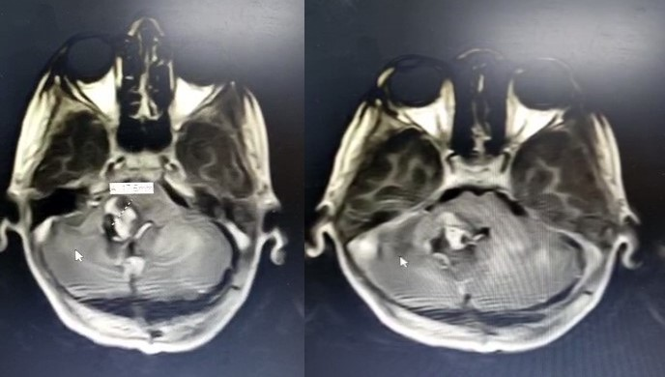

Figure1a: preoperative MRI T1 weighted image showing post fossa lesion

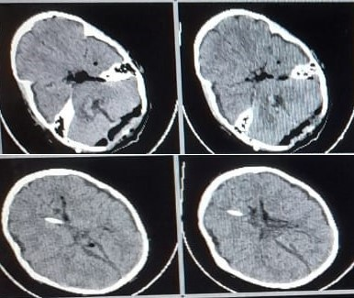

Figure 1b: postoperative CT brain showing excision of post fossa lesion and insertion of vp shunt

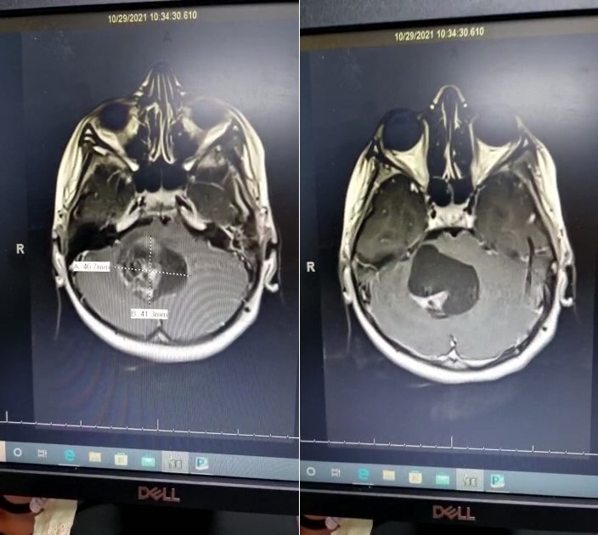

Fig 2a: T1 weighted image of MRI with contrast showing right sided post fossa lesion

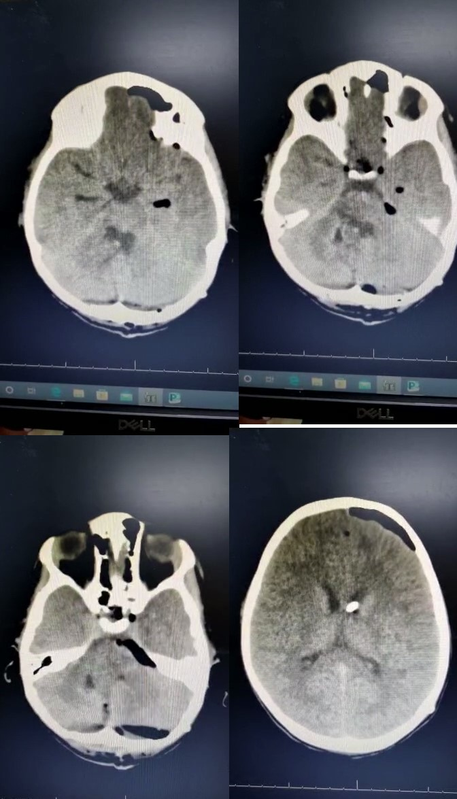

Figure 2b: postoperative CT brain showing total excison of posterior fossa lesion

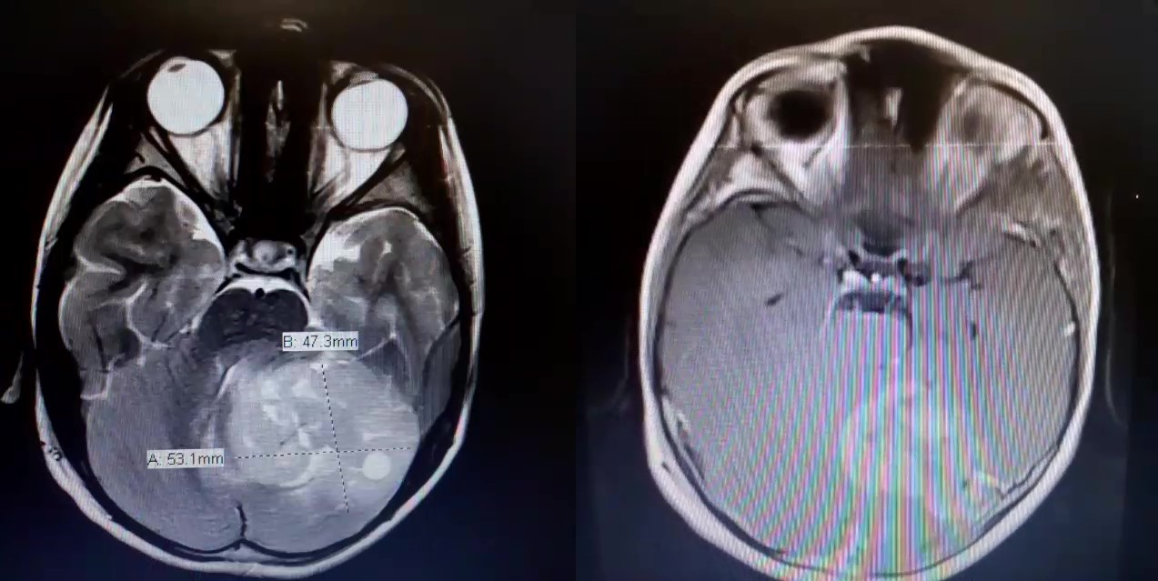

Figure 3a: T2 wieght image showing lt sided posterior fossa lesion

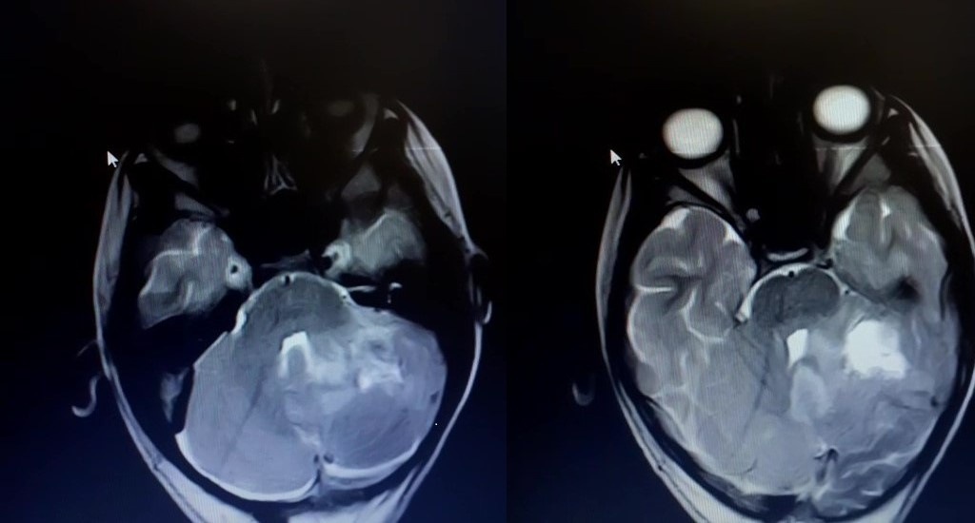

Figure 3b: T2 wieghted image MRI showing excision of lt sided posterior

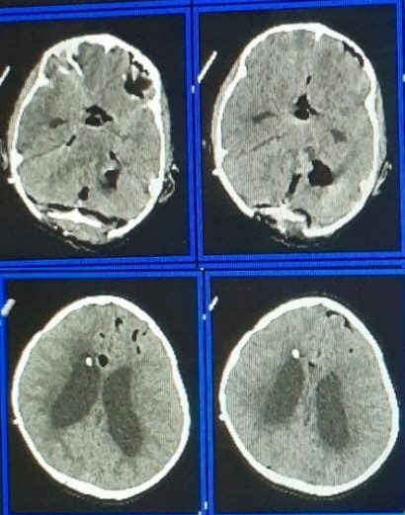fossa lesion

Fig 3c: Postoperative Ct brain showing Excision of Posterior fossa lesion