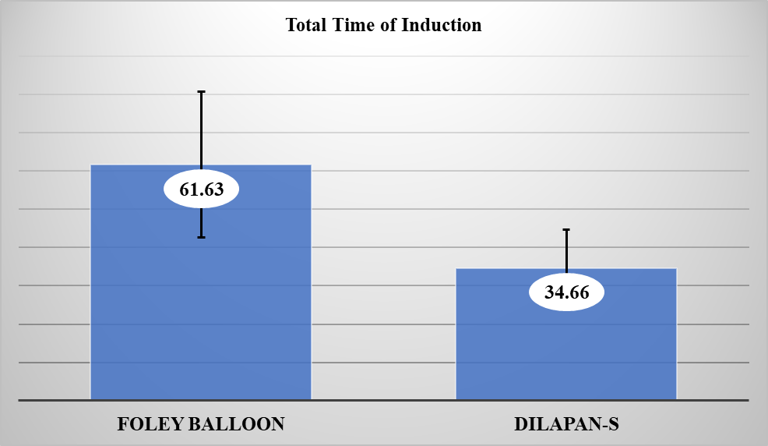

**Figure (1): Total Time of Induction of termination with Dilapan-S versus Foley balloon.**

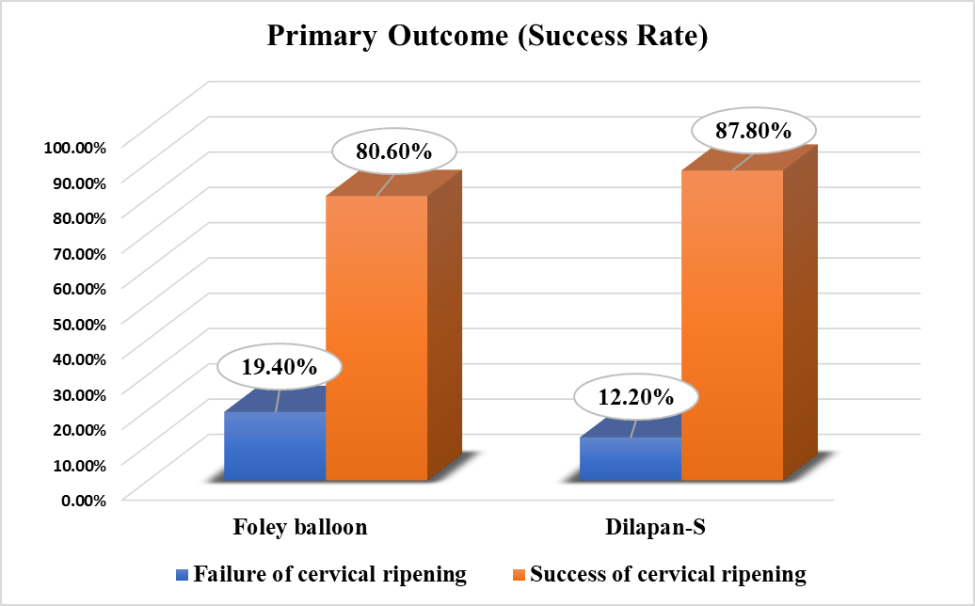

**Figure (2): Distribution of the studied women by Primary Outcome of Induction of termination according to Different Methods of Induction.**