Figure 1: Patient positioning

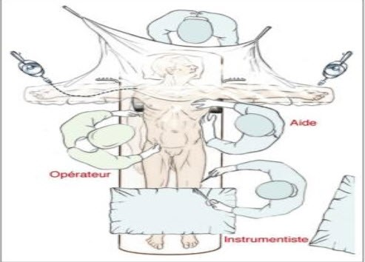

Figure 2: Makuuchi’s incision or J incision and Midline incision

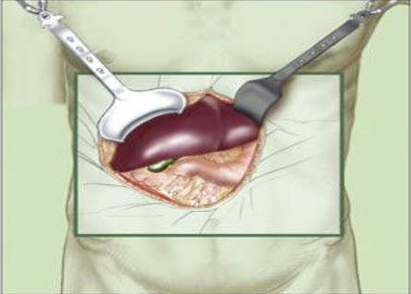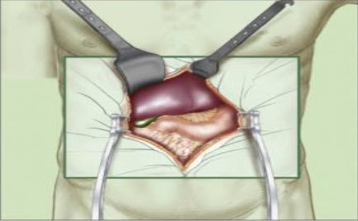

**Figure 3: type of resection of the studied group**

**Figure 4: blood loss during parenchymal transection and parenchymal transection time.**

**Figure 5: correlation between Total operative blood loss and hospital stay**

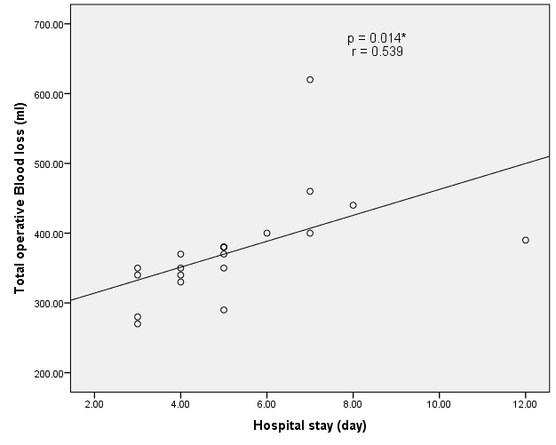

**Figure 6: C.T abdomen showing multilocular hepatic cystic lesion in segment VI and VII**

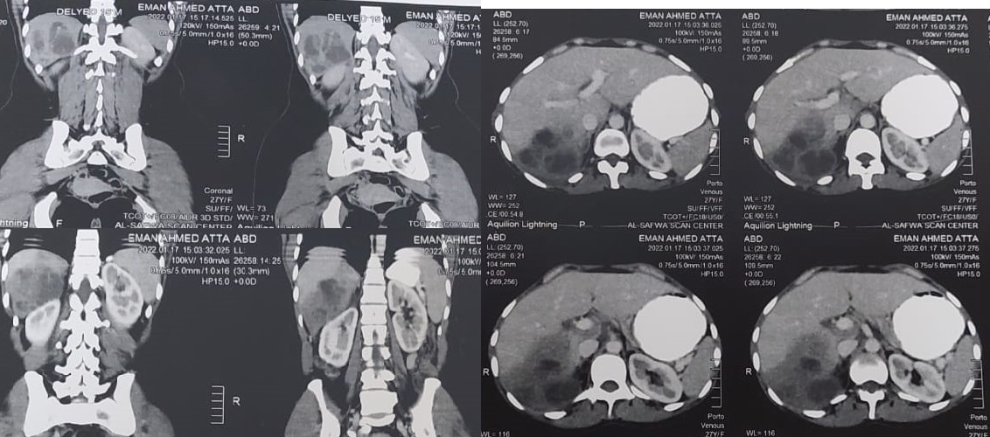

**Figure 7: Division of falciform ligament (Mobilization of the liver)**

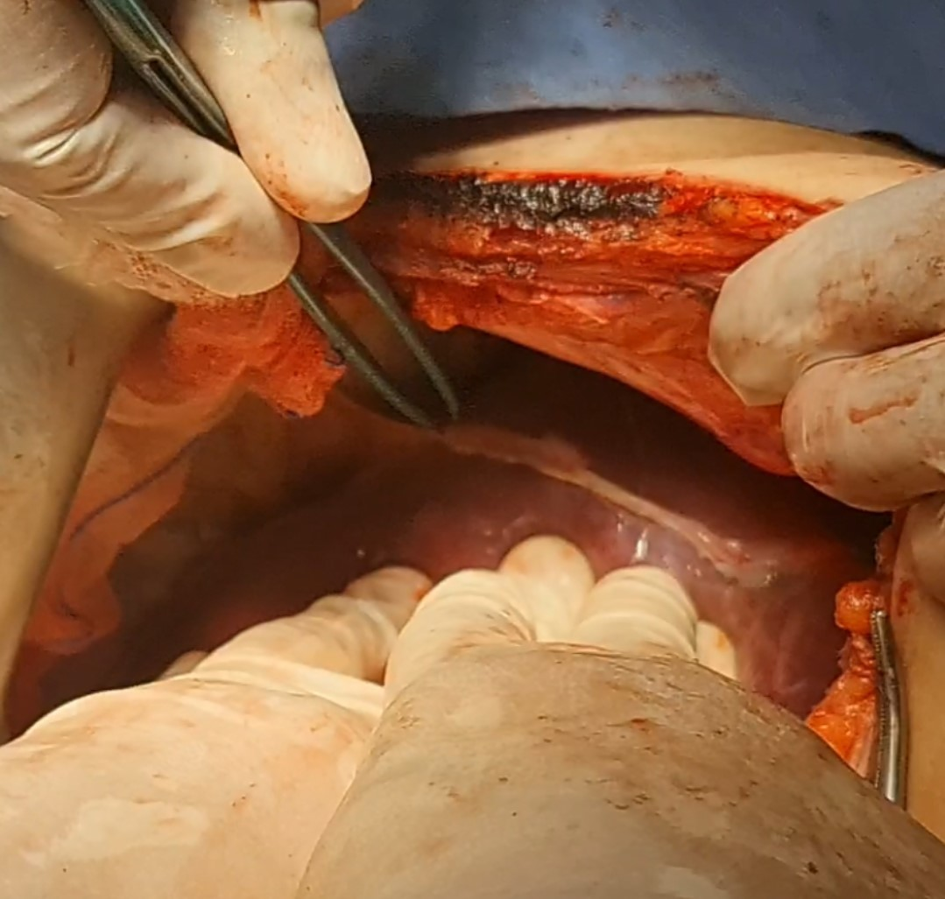

**Figure 8: IVC & Figure 4: RT. Hepatic vei**

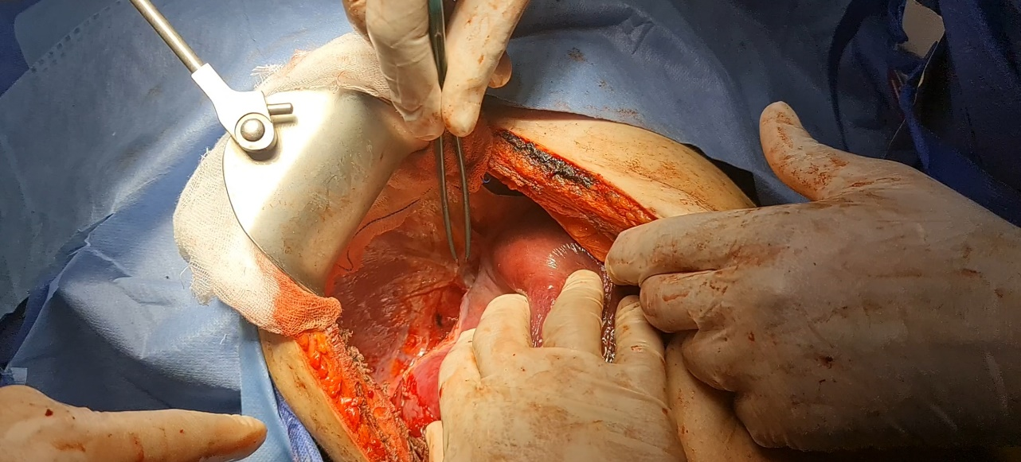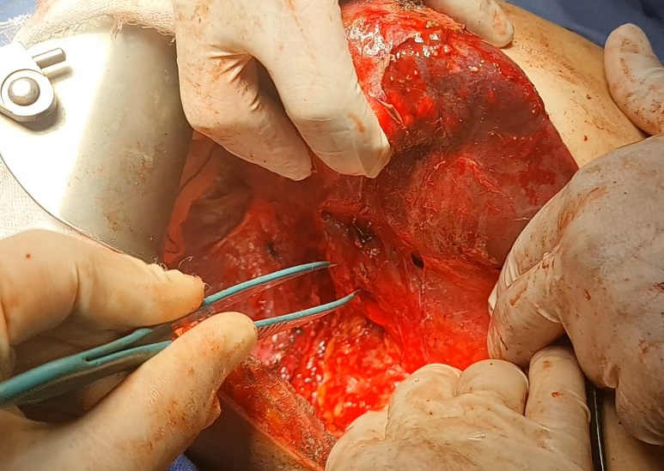

**Figure 9: Hepatic cystic lesion in segments VI and VII**

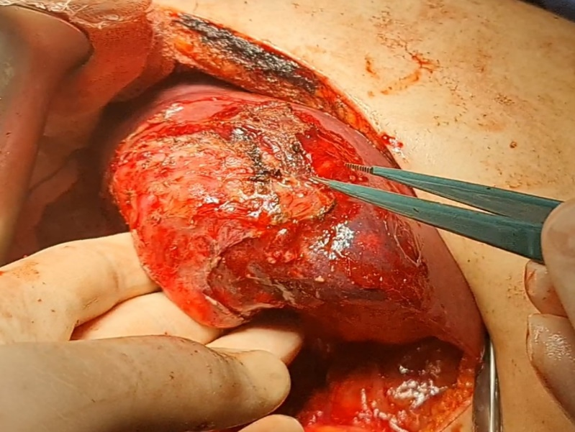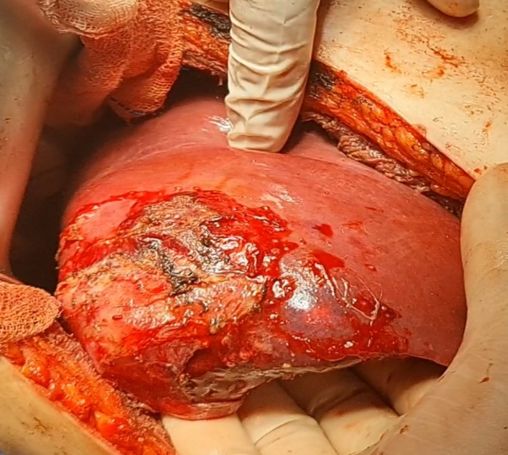

**Figure 10: Transection of hepatic parenchyma by harmonic scalpel**

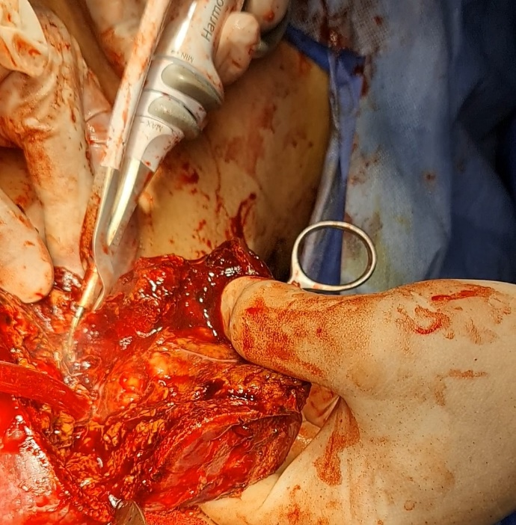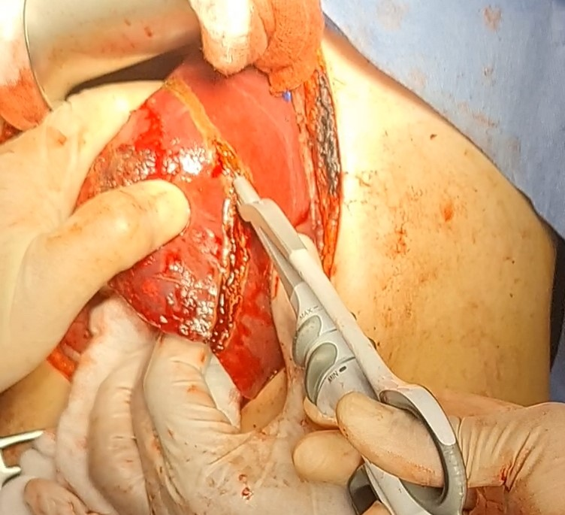

**Figure 11: Transection of hepatic parenchyma by CUSA**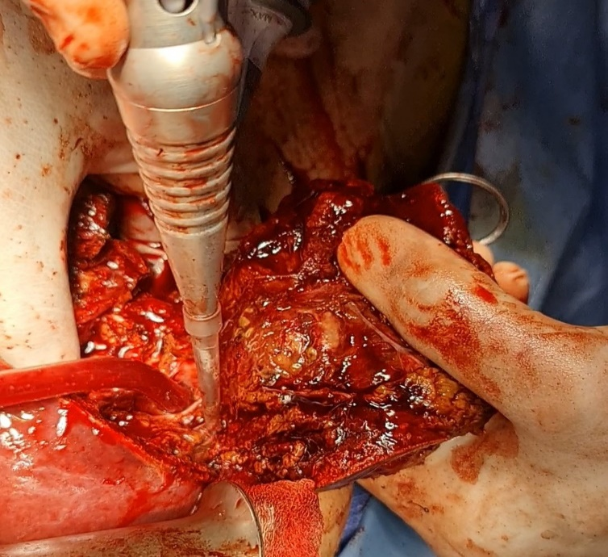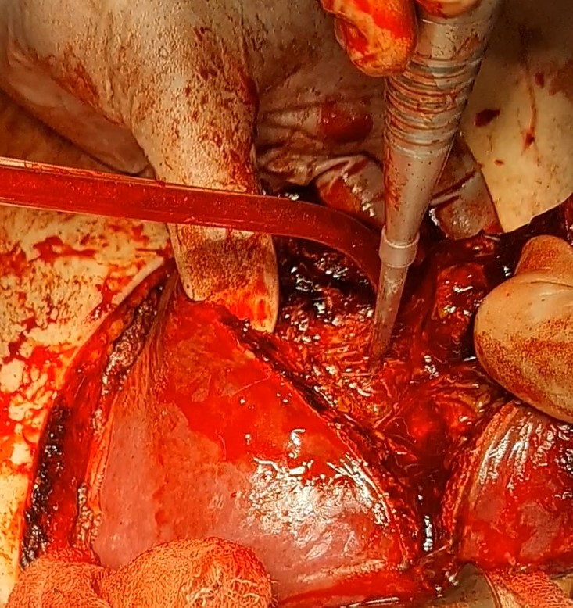

**Figure 12: Liver bed after resection**

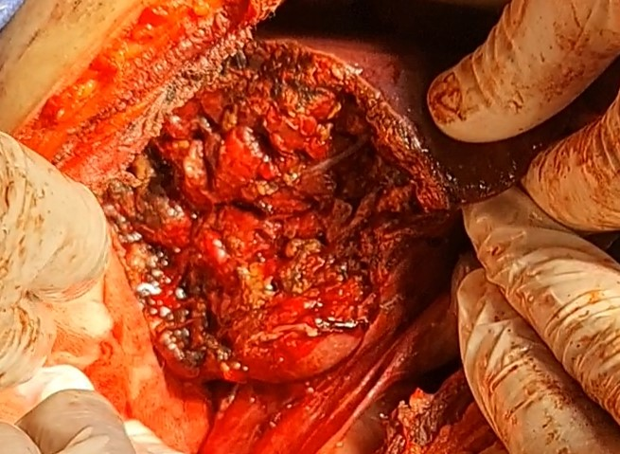

**Figure 13: The specimen of case 1 and Cut section of the resected segment.**

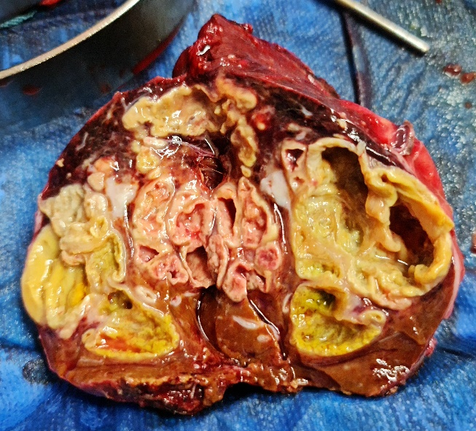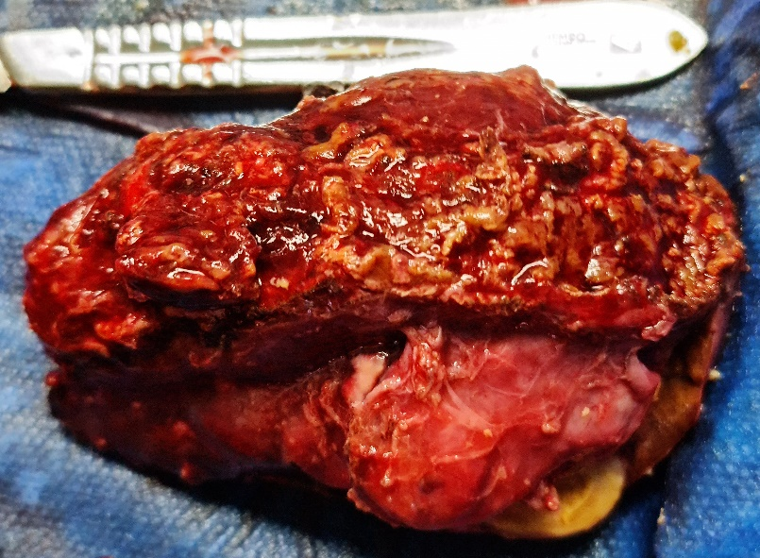

**Figure 14: J-shaped incision**

