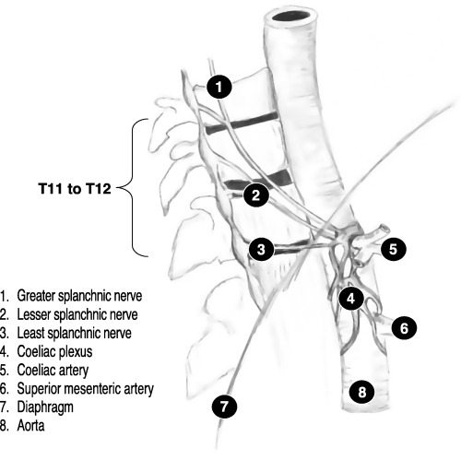

Anatomy of splanchnic nerves

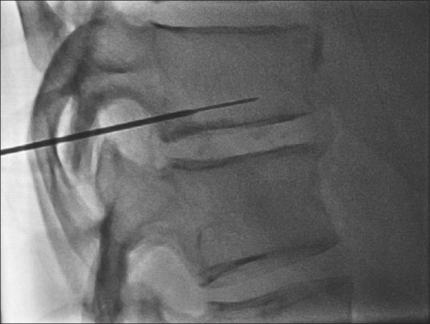

Fluoroscopic guided identification of thoracic vertebra no.11

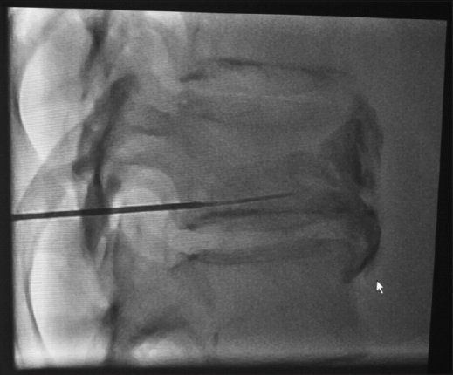

Injection of local anaethetic and alcohol under fluroscopy

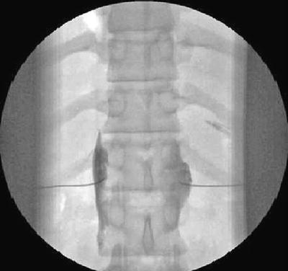

Ensuring bilateral distribution of the injction

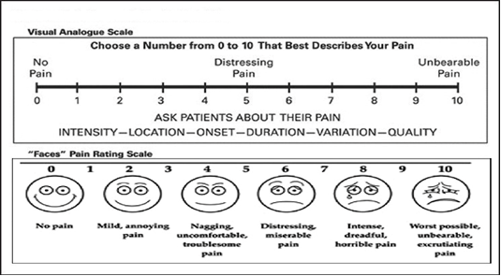

Visual analougr scale csore figure