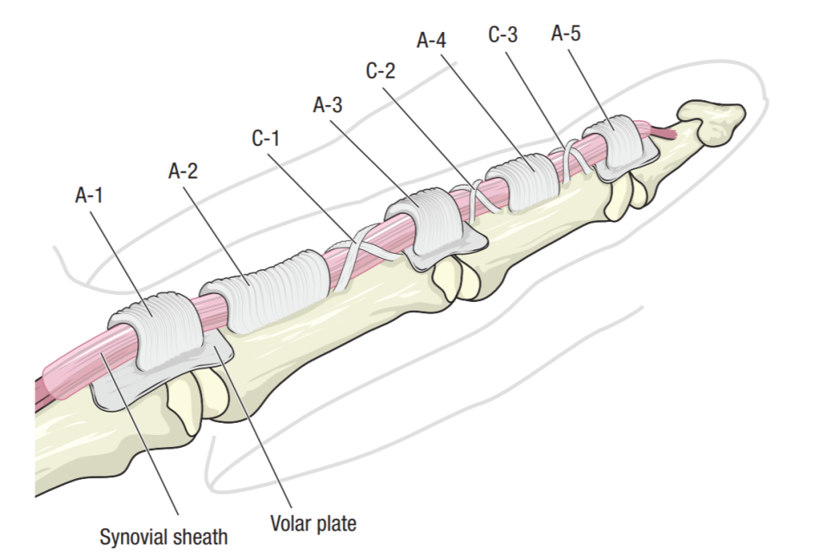

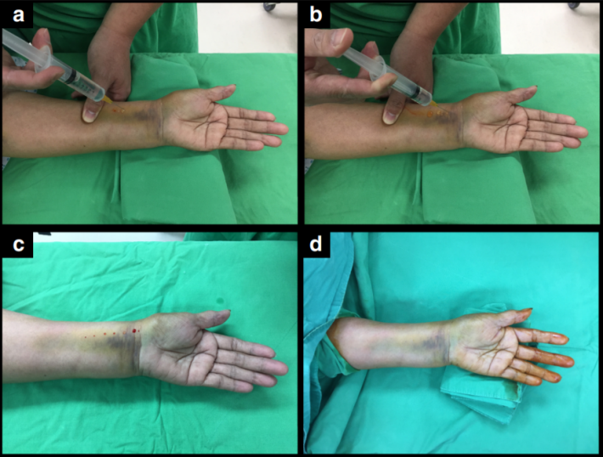

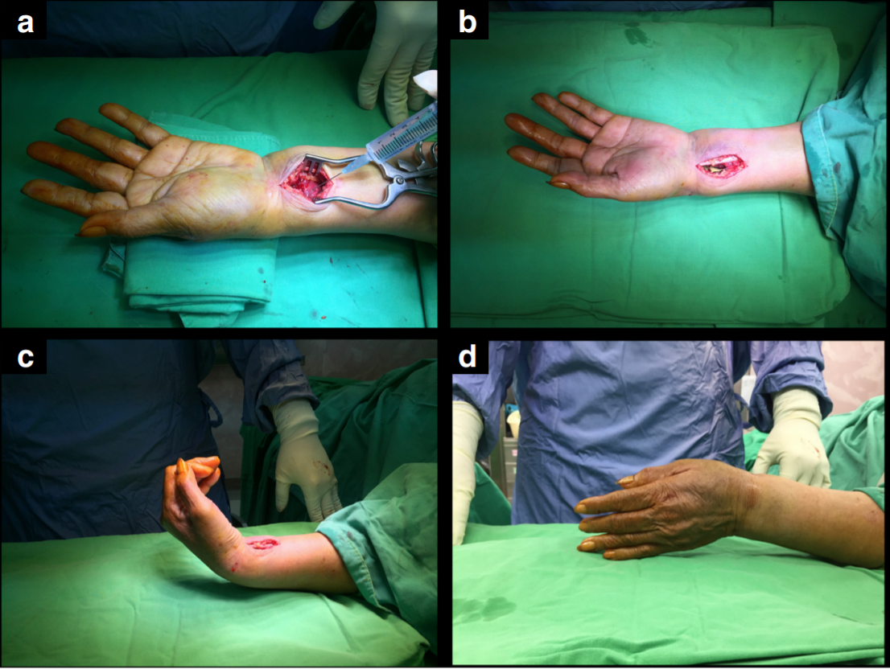

|  | | **Group A**  **(WALANT group) (n = 50)** | | **Group B**  **(conscious sedation group) (n = 50)** | | **Test value** | **P-value** | **Sig.** |
| --- | --- | --- | --- | --- | --- | --- | --- | --- |
| **N** | **%** | **N** | **%** |
| **Weight (Kg)** | **Mean± SD** | 81.42± 10.19 | | 79.74± 8.90 | | ZMWU= 0.738 | 0.460 | NS |
| **Median** | 79.0 | | 77.0 | |
| **Range** | 65.0- 110.0 | | 66.0- 109.0 | |
| **Hypertension** | **No** | 43 | 86.0% | 44 | 88.0% | X2= 0.088 | 0.766 | NS |
| **Yes** | 7 | 14.0% | 6 | 12.0% |
| **DM** | **No** | 44 | 88.0% | 47 | 94.0% | X2= 1.099 | 0.295 | NS |
| **Yes** | 6 | 12.0% | 3 | 6.0% |
| **Other** **comorbidities** | **No** | 48 | 96.0% | 44 | 88.0% | X2= 2.174 | 0.140 | NS |
| **Yes** | 2 | 4.0% | 6 | 12.0% |

|  | | **Group A**  **(WALANT group) (n = 50)** | **Group B**  **(conscious sedation group) (n = 50)** | **Test value** | **P-value** | **Sig.** |
| --- | --- | --- | --- | --- | --- | --- |
| **Duration of surgery** | **Mean± SD** | 34.62± 6.28 | 30.66± 4.61 | ZMWU=3.387 | **0.001** | HS |
| **Median** | 35.0 | 30.0 |
| **Range** | 21.0- 48.0 | 22.0 – 40.0 |

p≤0.05 is considered statistically significant, p≤0.01 is considered high statistically significant,

SD= standard deviation, comparison between groups done by Mann-Whitney test

|  | | **Group A**  **(WALANT group)**  **(n = 50)** | | **Group B**  **(conscious sedation group)**  **(n = 50)** | | **Test value** | **P-value** | **Sig.** |
| --- | --- | --- | --- | --- | --- | --- | --- | --- |
| **N** | **%** | **N** | **%** |
| **Blood loss** | **No** | 3 | 6.0% | 38 | 76.0% | X2= 50.64 | **<0.001** | HS |
| **Yes** | 47 | 94.0% | 12 | 24.0% |
| **Amount of blood loss** | **Mean± SD** | 59.0± 29.78 | | 12.0± 21.57 | | ZMWU=7.149 | **<0.001** | HS |
| **Median** | 50.0 | | 0.0 | |
| **Range** | 0.0- 150.0 | | 0.0 – 50.0 | |

|  | | **Group A**  **(WALANT group)**  **(n = 50)** | **Group B**  **(conscious sedation group)**  **(n = 50)** | **Test value** | **P-value** | **Sig.** | |
| --- | --- | --- | --- | --- | --- | --- | --- |
| **VAS score** | **Mean± SD** | 3.68± 1.79 | 6.94± 1.24 | ZMWU=7.305 | **<0.001** | HS |
| **Median** | 3.0 | 7.0 |
| **Range** | 0.0- 8.0 | 4.0 – 10.0 |