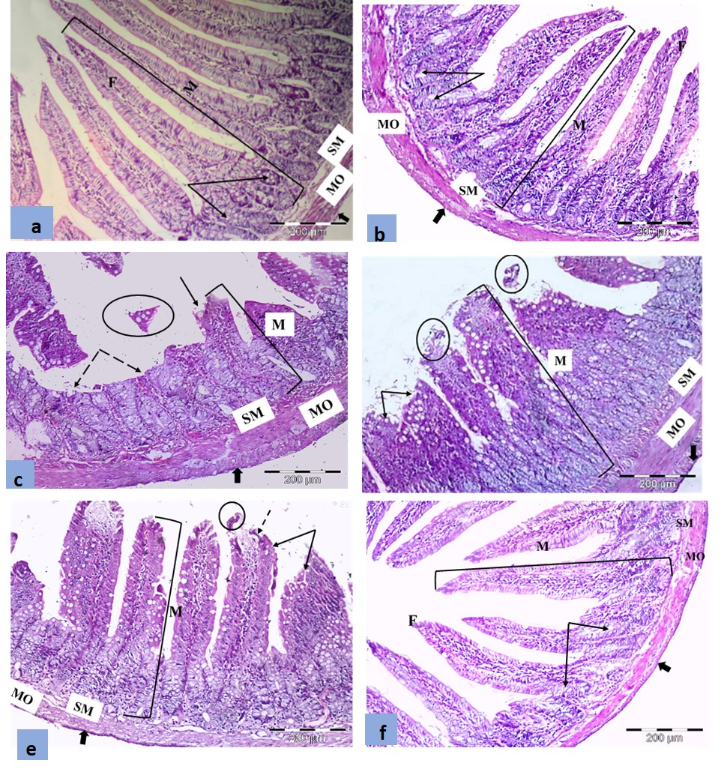
Fig 1

Fig 2

Figure. 1: Representative photomicrographs of jejunum in (a) control group and (b) probiotic groups: showing normal architecture; intestinal mucosa (M), submucosa (SM), musculosa (MO), and serosa (thick arrow). Notice the leaf like villi (F) covered with simple columnar epithelium with goblet cells and the jejunal crypts (arrows). (c) CP-2D group showing distorted villi (arrow) and shredded epithelial cells in the lumen (circle) with bared mucosal areas (dashed arrows). (d) CP-2W and (e) Prob-CP-2D groups showing short, broad villi (arrows) and shedding of the villus epithelium in the lumen (circles). (f) Prob-CP-2W group showing more or less normal leaf-like intestinal villi (F) and normal crypts (arrows). H & E X 400
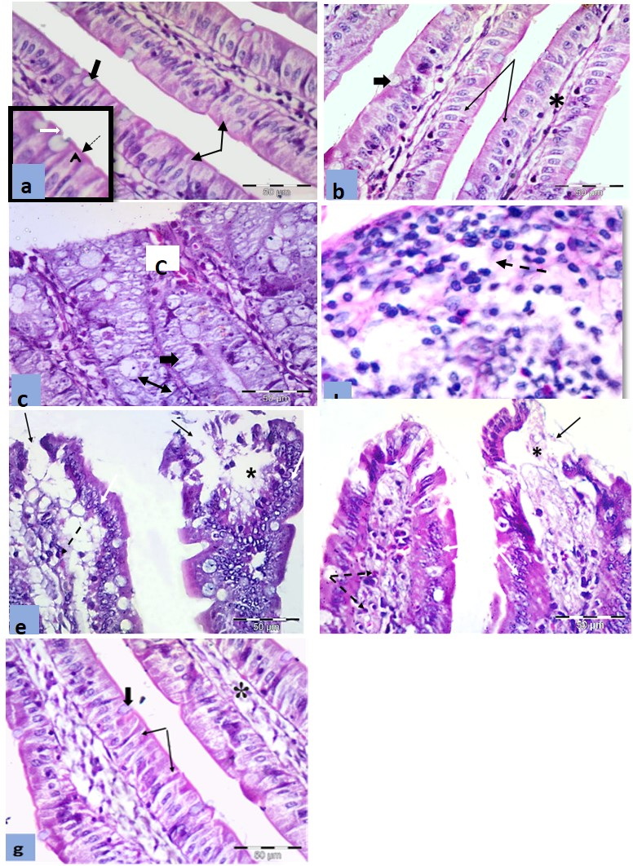
Fig 3

Figure. 2: Representative photomicrographs of the jejunum in (a) control and (b) probiotic groups showing the villi covered by enterocytes (arrows) and goblet cells (thick arrow) with a core of connective tissue (*). Notice enterocytes with oval pale basal nuclei and eosinophilic cytoplasm. Goblet cells with basal dark nuclei and broad apex filled with mucus. The inset is a higher magnification showing the regular striated brush border (dashed arrow), the terminal web (arrowhead) and the terminal bar (white arrow). (c) CP-2D group showing congested blood capillaries in the lamina propria (c). The cells lining the crypts showing ballooning and vacuolation (thick arrow) with pyknotic nuclei (double head arrow) and absence of the characteristic acidophilic granules of Paneth cells lining the crypts. (d) CP-2D group showing inflammatory cells (dashed arrow). (e) CP-2W and (f) Prob-CP-2D groups showing damaged villous lining with bared areas (arrows) with fewer inflammatory cell infiltration (dashed arrow). Notice the subepithelial space (*) and areas of stratification of polyhedral cells with rounded nuclei (white arrows). (g) Prob-CP-2W group showing more or less normal leaf like villi covered by enterocytes (arrows) and goblet cells (thick arrow) with a core of connective tissue (*). Notice normal appearance of enterocytes with oval pale basal nuclei and eosinophilic cytoplasm and goblet cells with basal dark nuclei and broad apex filled with mucus. H & E X 400; inset X1000
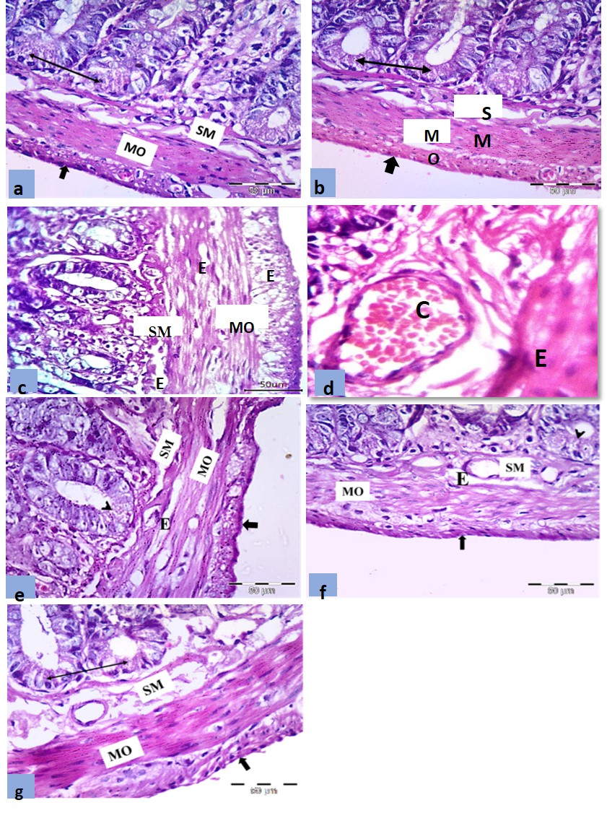
Fig 3

Figure.3: Representative photomicrographs of the jejunum in (a) control and (b) probiotic groups showing the apparent normal crypts in the lamina propria, the submucosa (SM), musculosa (MO) and serosa (thick arrow). Notice the Paneth cells (double head arrows) deep in the crypts with their large apical eosinophilic granules. (c) CP-2D group showing edema (E) in submucosa (SM) and in muscle layers (MO). (d) CP-2D group showing congestion (c) in submucosa. (e) CP-2W and (f) Prob-CP-2D group showing reappearance of some acidophilic granules in few Paneth cells (arrow head) while musculosa showing areas of edema (E). (g) Prob-CP-2W group showing absence of congestion, inflammatory cell infiltration or edema, and most Paneth cells with their characteristic acidophilic granules (double head arrow) The muscle fibers were orderly arranged, and the serosa was apparent normal. H & E X 400
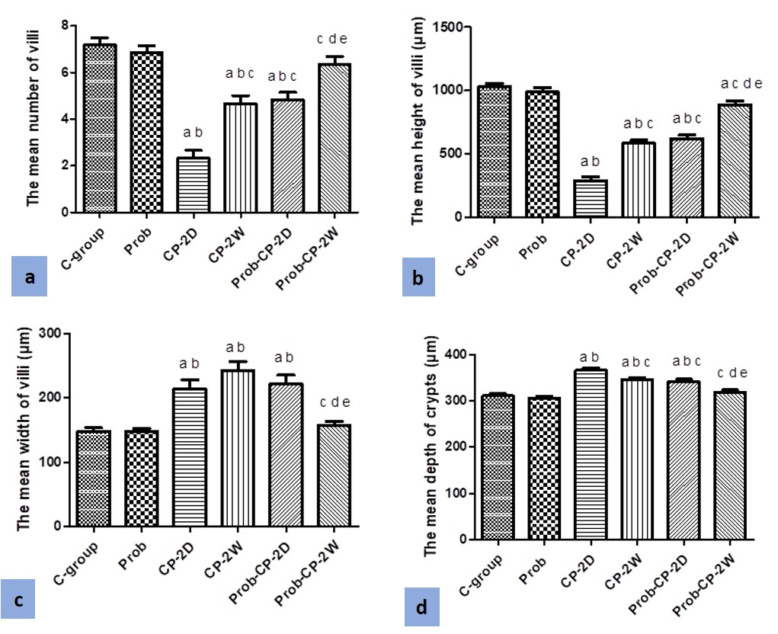
Fig 4

Figure. 4: (a) the mean number of villi of jejunum in the studied groups (n=6), (b) the mean height of the villi (µm) (c) the mean width of the villi (µm) (d the mean depth of the crypts (µm) in the jejunum in the studied groups (n=6). a: significant vs C-group, b: significant vs Prob-group, c: significant vs CP-2D, d: significant vs CP-2W, e: significant vs Prob-CP-2D

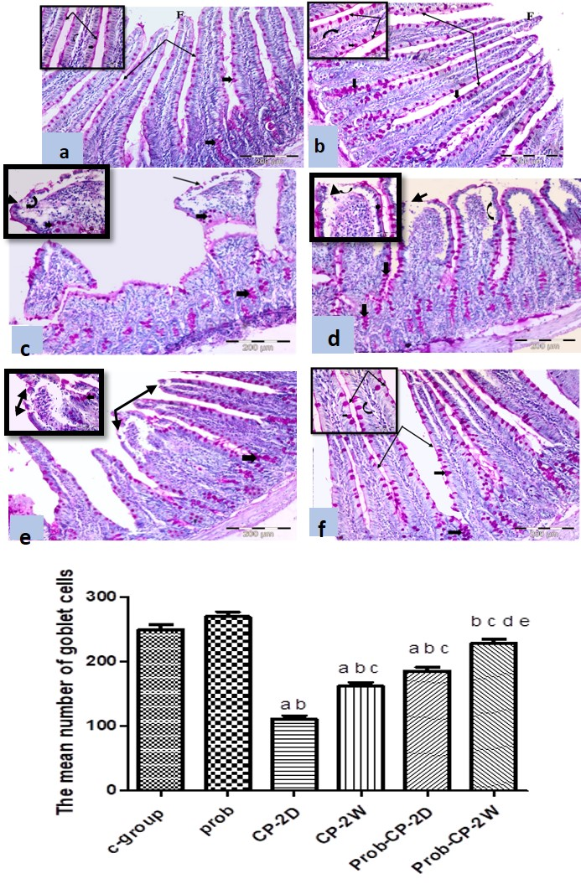
Fig 5

F igure. 5: The representative photomicrographs of the jejunum in (a) control and (b) probiotic groups showing the intact PAS stained brush borders (arrows) and basement membranes (curved arrow) of the enterocytes and the PAS stained mucus in the scattered goblet cells (thick arrows) in the villi (F) and crypt lining. (c) CP-2D group showing loss of most apical PAS positive brush borders (arrows) and basement membranes (curved arrow) of enterocytes in damaged villi. Notice the marked decrease in goblet cells (thick arrows) within a disturbed lining. (d) CP-2W and (e) Prob-CP-2D groups showing decreased areas of focal loss of the PAS stained brush borders (arrows) and basement membranes of the enterocytes (curved arrows) with apparent increase in the number of goblet cells (thick arrows). (f) Prob-CP-2W group showing preserved PAS positive reaction of most brush borders (arrows) and basement membranes (curved arrow) of the columnar cells of the villi and apparent more increase in the number of the goblet cells (thick arrows). PAS X400. (g): The mean number of goblet cells in the jejunum in the studied groups (n=6)

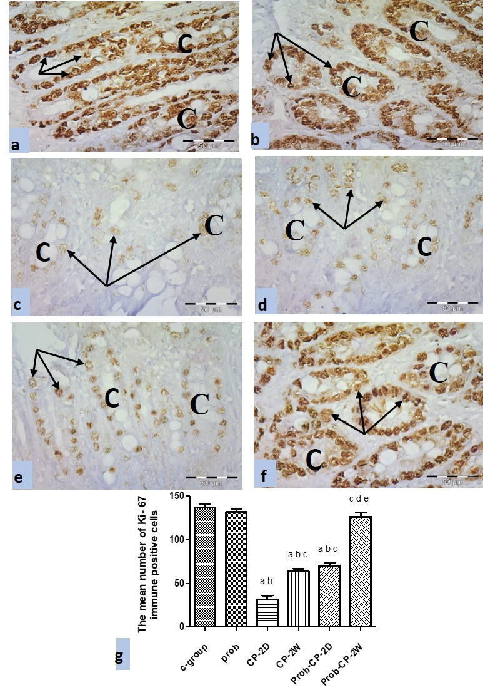
Fig 6

Figure. 6: The representative photomicrographs of the jejunum in (a) control and (b) probiotic groups showing numerous Ki-67 immune positive nuclei (arrows) in epithelial cells lining the crypts (C). (c) CP-2D group showing marked decrease in Ki-67 immune positive nuclei (arrows) in epithelial cells lining the crypts (C). (d) CP-2W and (e) Prob-CP-2D groups showing a relative increase of Ki-67 immune positive nuclei (arrows) in epithelial cells lining the crypts (C). (f) Prob-CP-2W group showing numerous Ki-67 immune positive nuclei (arrows) in epithelial cells lining the crypts (C). Ki-67 X400. (g) The mean number of Ki-67 positive cells in the studied groups (n=6) a: significant vs C-group, b: significant vs Prob-group, c: significant vs CP-2D, d: significant vs CP-2W, e: significant vs Prob-CP-2D .
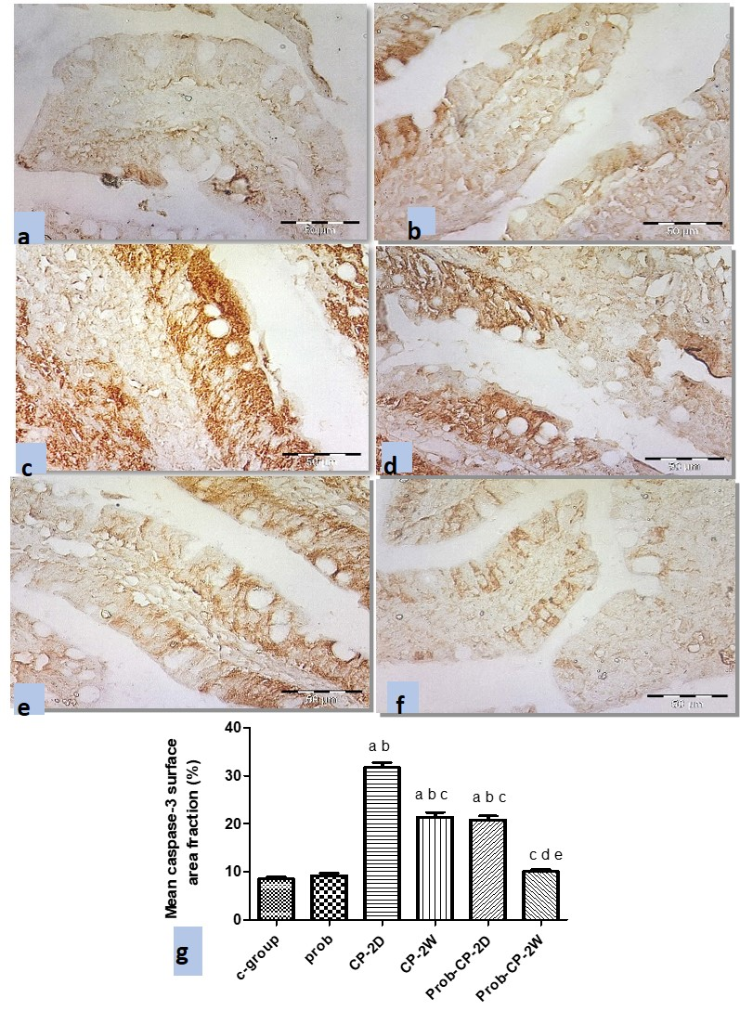
Fig 7

Figure. 7: The representative photomicrographs of the jejunum in (a) control and (b) probiotic groups showing immune reactivity for activated caspase-3 scattered in some epithelial cells of the lining of villi (arrows) of jejunal mucosa. (c) CP-2D group showing extensively increased immune positive cells in the lining of villi (arrows). (d) CP-2W and (e) Prob-CP-2D groups showing less immune positive cells in the lining of the villi (arrows). (f) Prob-CP-2W group showing marked decreased immune positive cells in the lining of the villi (arrows). caspase-3 X400. (g) the mean caspase-3 surface area fraction in the studied groups (n=6) a: significant vs C-group, b: significant vs Prob-group, c: significant vs CP-2D, d: significant vs CP-2W, e: significant vs Prob-CP-2D.

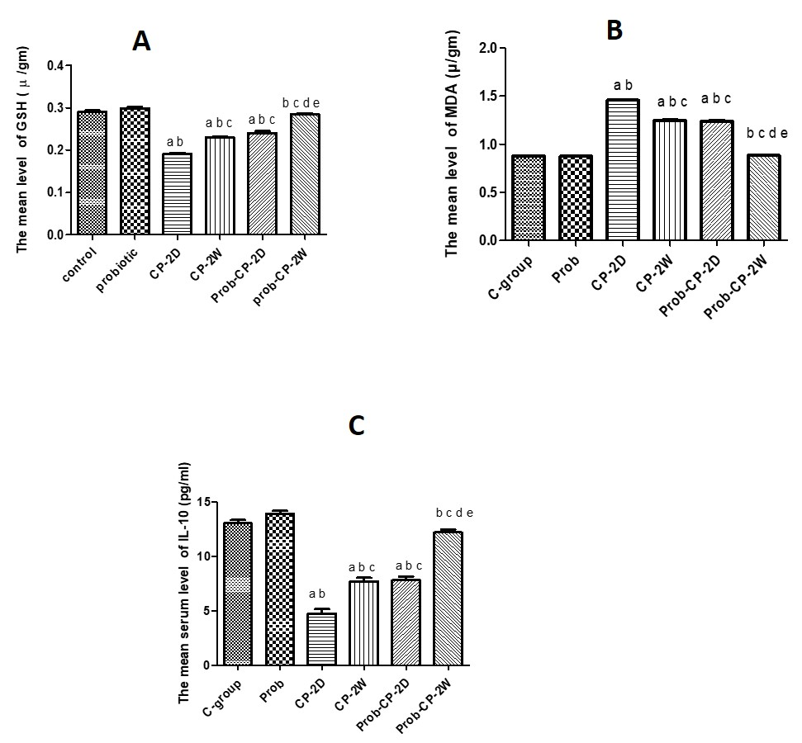
Fig 8

Fig 8 A) The mean level of jejunal MDA (µ/gm) in the studied groups (N=6), B) The mean level of jejunal GSH (µ/ gm) in the studied, C) The mean serum level of IL-10 (pg / ml) in the studied groups a: significant vs C-group, b: significant vs Prob-group, c: significant vs CP-2D, d: significant vs CP-2W, e: significant vs Prob-CP-2D

