Fig. 1: The mean percentage of reduction of hair count before and after 1 month after treatment.

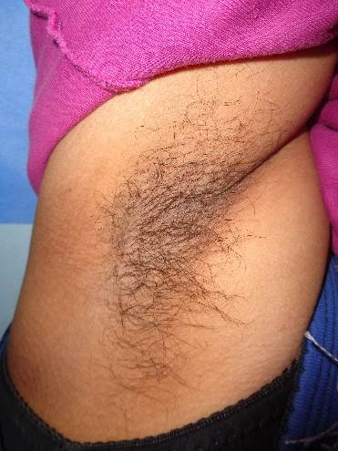
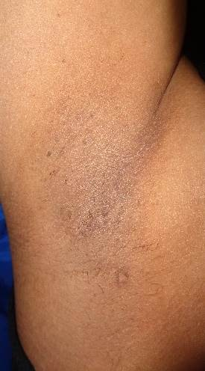

B
A

Fig. 2: right axilla in female subject: (a) At baseline, (b) At 1 month after last session.

