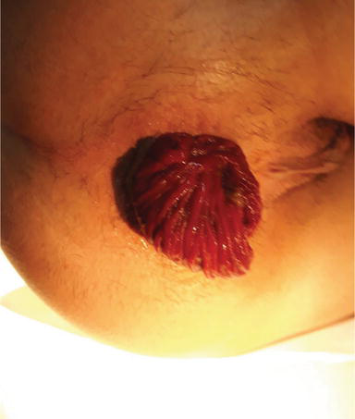

Figure1:Complete rectal prolapse
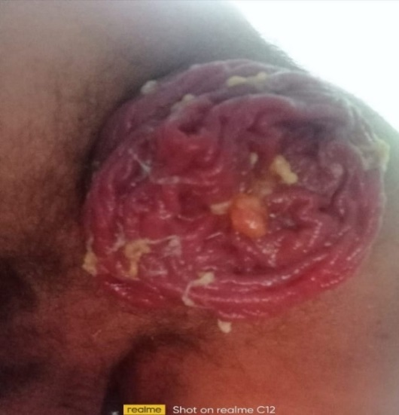

Figure2:Complete rectal prolapse.

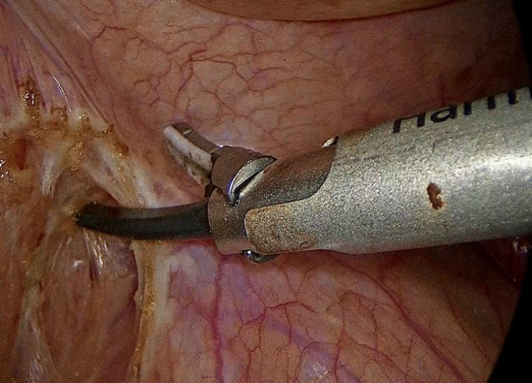

Figure 3 :mobilization of the rectum
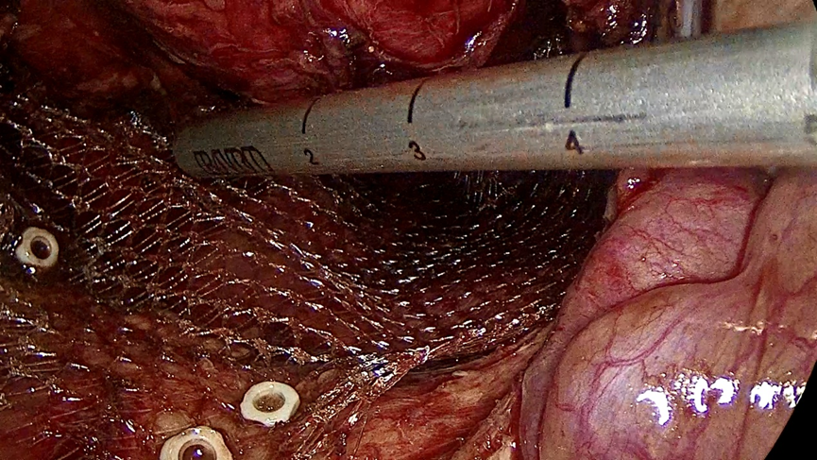

Figure 4: Presarcral fascia and periosteum at the level of the promontory.

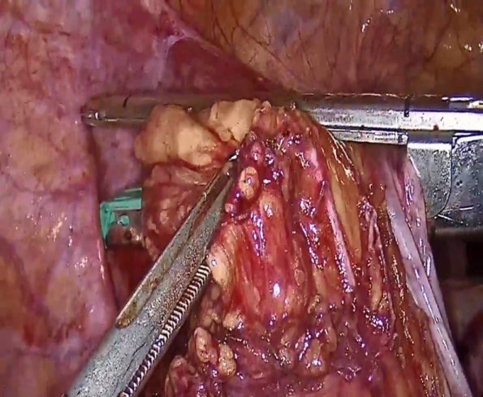
Figure5 :resection of the colon.

Figure5 :resection of the colon.
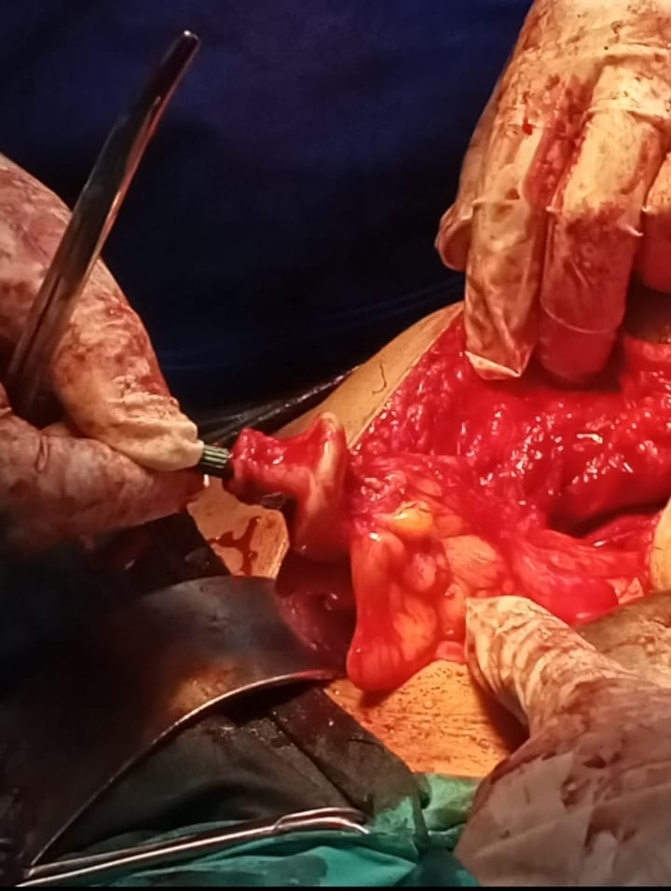

Figure6: suturing the anvil part of the circuler stapler at the proximal anastmotic end.

