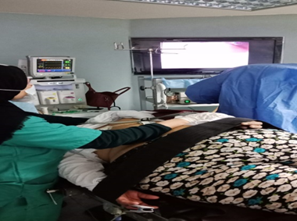

Figure 1. position of the patient during ERCP

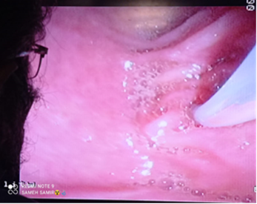**Figure 2, Successful CBD cannulation**

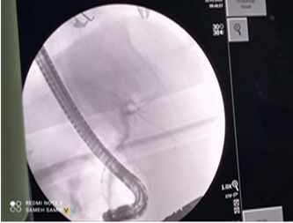

**figure3 choleangiogram**

**figure 5, ballon sweeping of CBD**

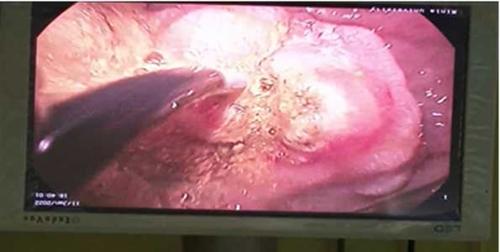

**figure 4**

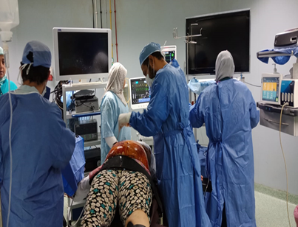figure 5 Patient position during anesthesia

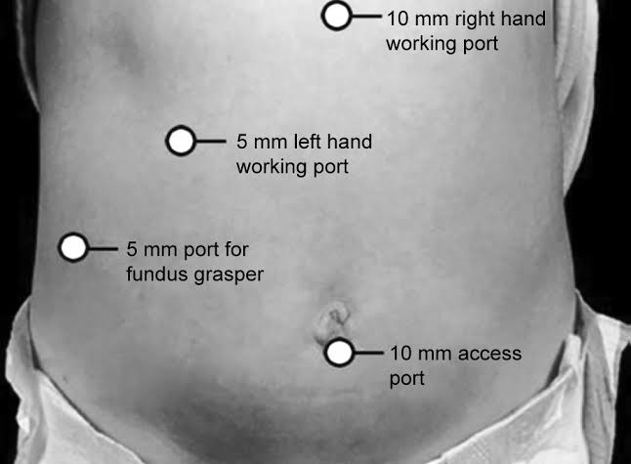

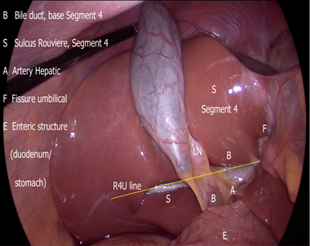

Figure 6 critical view

Figure .7 trocars sites