**CASE PRESENTATION**

**CASE NO 1**

**History** :

18 years old female patient presented with chronic vomiting 2 years ago.

**By US and CT findings:**

Normal

**BY MR Enterography findings:**

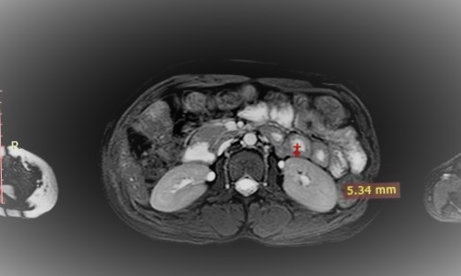

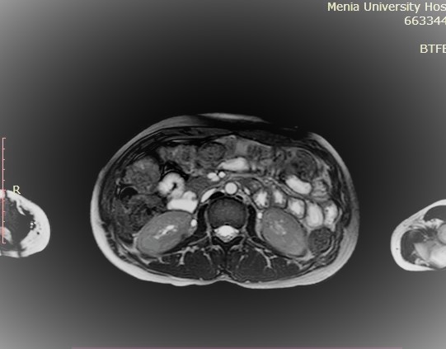

Fig a Axial BTFE- SPAIR -ax image showing moderate diffuse thickening of the jejunal loops, (thickness about 5mm).

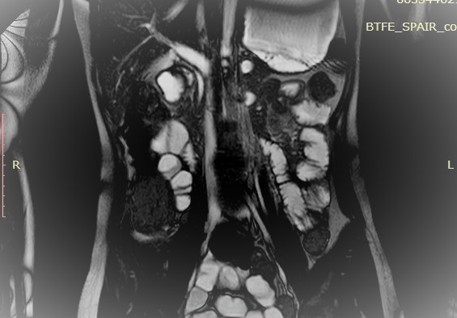

Fig b BTFE- SPAIR –cor image showing thickening of the jejunum loops as well as mild haziness of the related fat planes

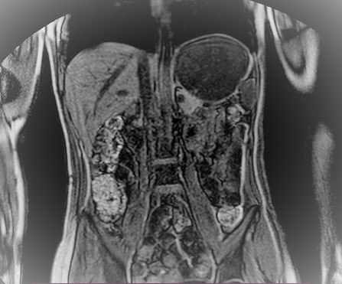

Fig c e-THRIVE-cor image showing thickening of the wall of the jejunum loop ,normal wall thickness of other small and large bowel loops.

**BY Endoscopy and biopsy**

proved to be nonspecific Inflammatory condition.

**CASE NO 2**

**History :**

20 years old male patient present with weight loss and easily fatigability .

**By US and CT findings :**

Us :multiple mesenteric LN enlargement some of them showing loss of fatty hilum .

CT: lobulated soft tissue mass lesion seen at the right lumber region.

**MR Enterography findings:**

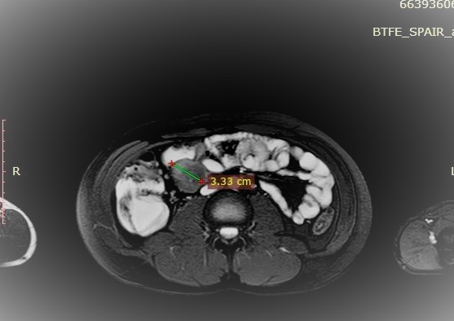

Fig a BTFE-SPAIR-ax image showing a rounded well defined abnormal signal intensity of soft tissue mass lesion seen related to the distal ileal loops ,measuring about 3.5cm with peripherally relaitevely hyper intense margin .

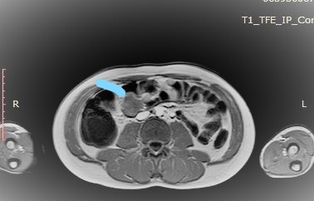

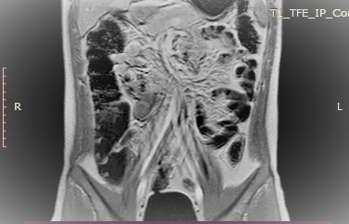

Fig c T1-TFE-IP- image after IV contrast injection showing a hypo intense signal at T1W with faint enhancement after post contrast study .

**By biopsy:**

proved to be malignant round small cell tumor

**CASE NO 3**

**History :**

57 years old Female patient presented with abdominal pain, constipation and vomiting with history of previous two operations .

**By US and CT findings :**

Us : mildly distended bowel loops with more or less sluggish motility with mild intra peritoneal fluid collection.

CT : distended bowel loops with air fluid level with mild amount of fluid collection.

**MR Enterography findings:**

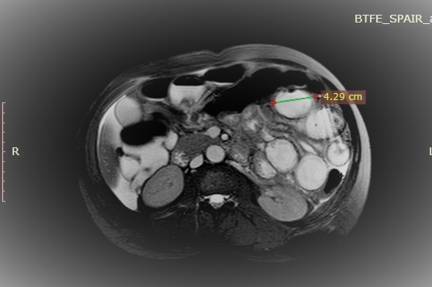

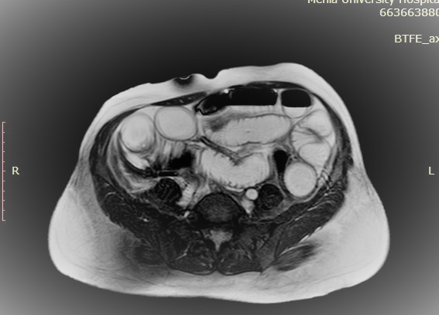Fig a BTFE-SPAIR-ax image showing mildly dilated jejunal loops (caliber measuring about 4.2cm ) r with normal wall thickness.no definite lesion could be detected . 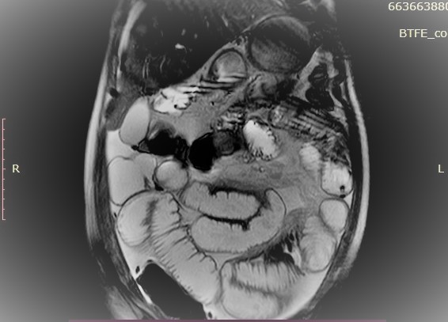

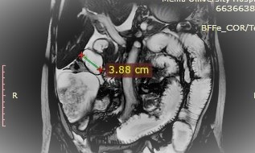

Fig b BFFe-COR/Test showing dilated ilium loops .measuring about 3.8 cm in caliber with normal wall thickness.no definite lesion could be detected .

**By Colonoscopy and biopsy :**

Bowel dilated with no obstruction lesion.

.