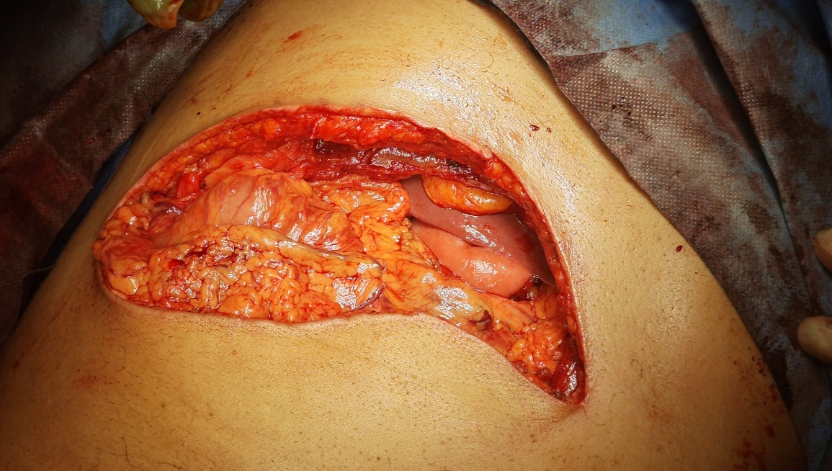

**Fig (1): Incision in pancreaticoduodenectomy: Bilateral subcostal incision**

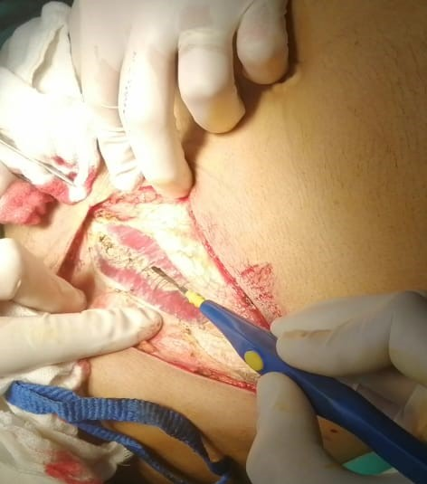

**Figure (2): Incision layers of the abdominal wall**

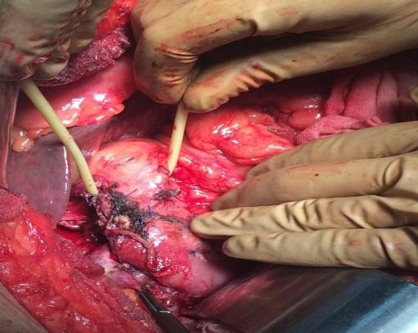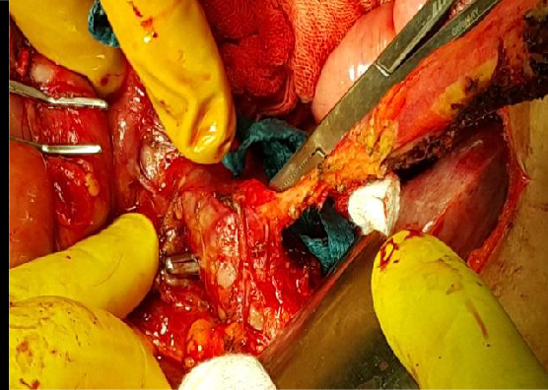

**Fig (3): Mobilized pancreas before division**

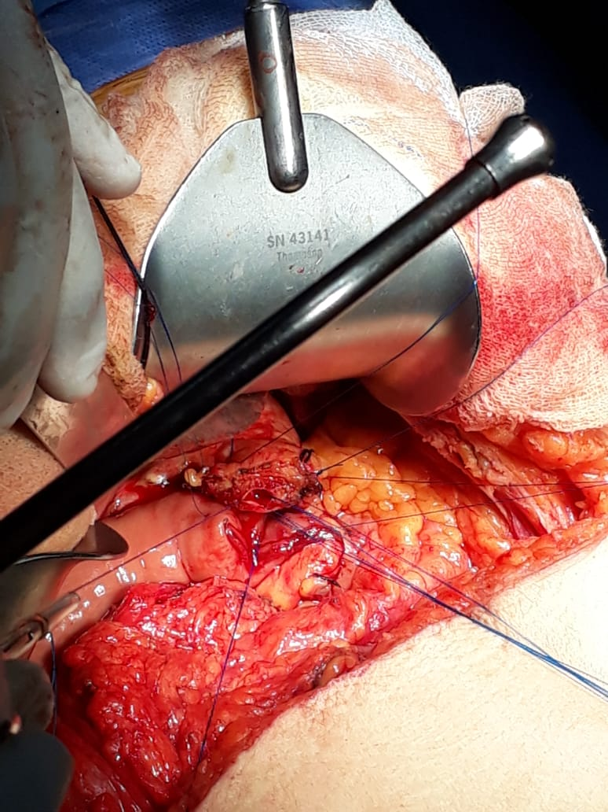

**Fig (4): Pancreatic duct anastomosis (duct to mucosa anastomosis)**

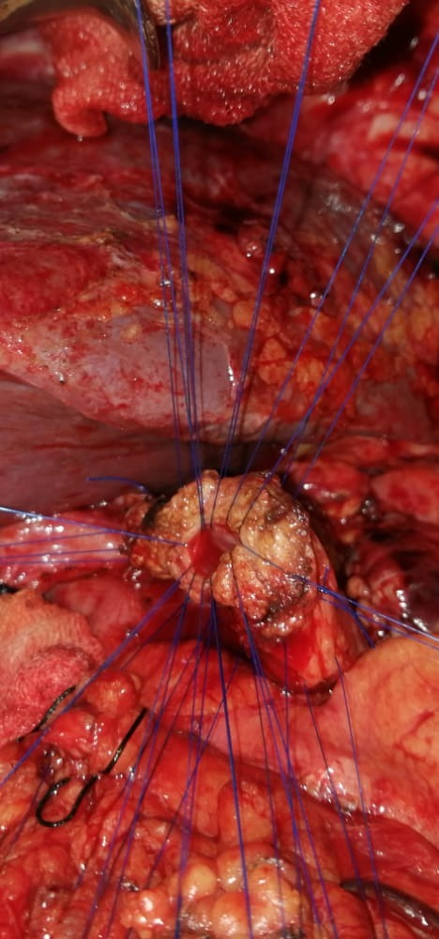

**Fig (5): Pancreatic duct anastomosis (duct to mucosa anastomosis)**

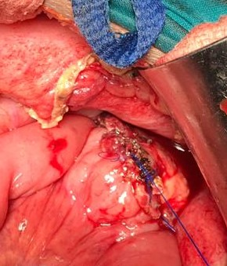

**Fig (6): Invagination technique**

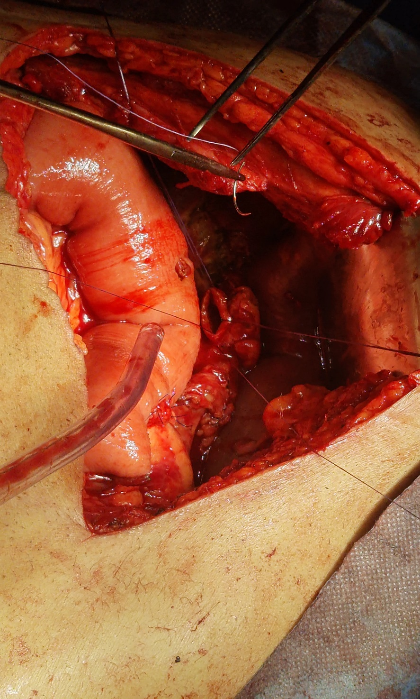

**Figure (7): Divided CBD prepared for hepaticojejunostomy**

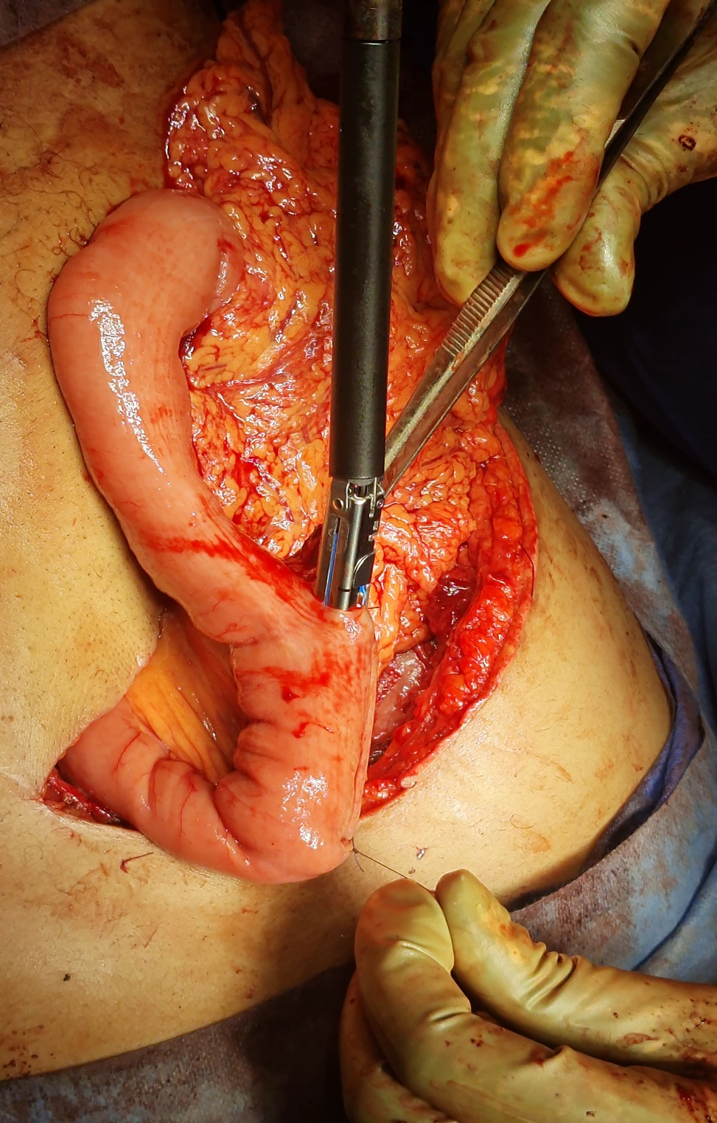

**Fig (8): Gastrojejunostomy anastomosis**