[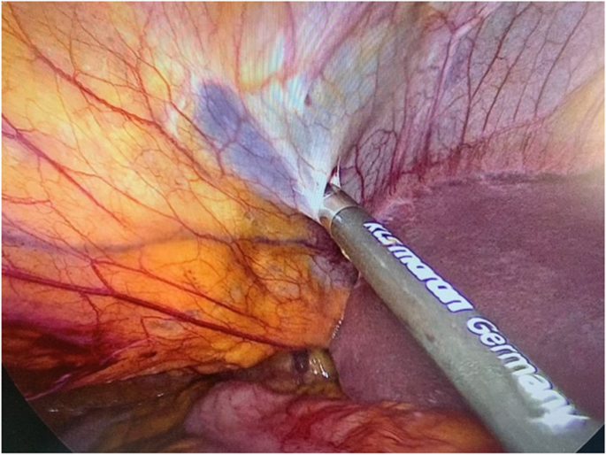](https://link.springer.com/article/10.1007/s00423-021-02284-9/figures/3)

**Figure (1) Dissection of the ligamentum teres from the ligamentum falciforme and the anterior abdominal wall using a harmonic device.**

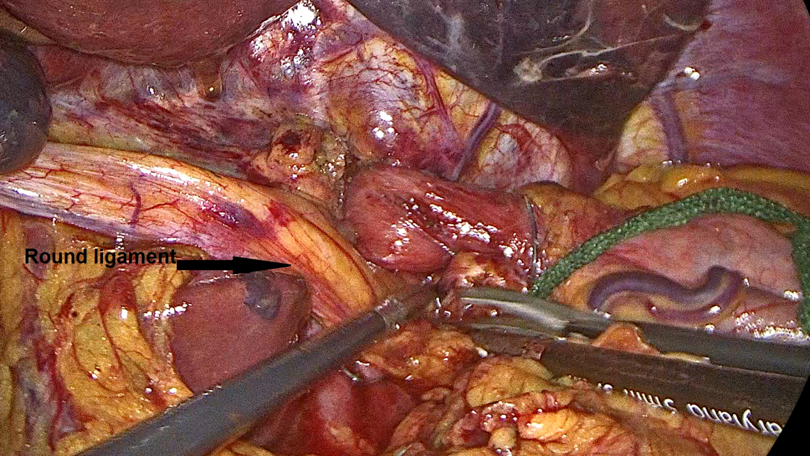 **figure (2) Round Ligament dissected from its origin to reinforce crural repair.**