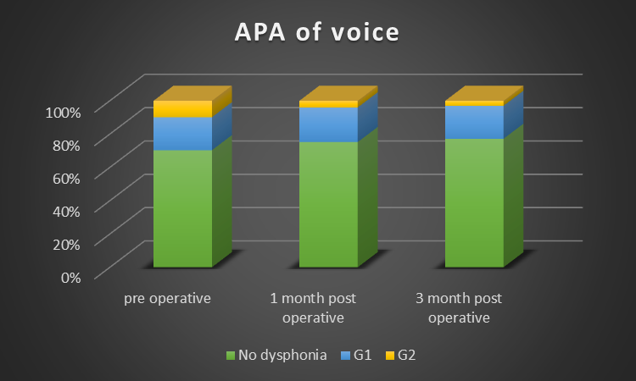
Figure 1 As regard APA of voice:regardless the types of techniques

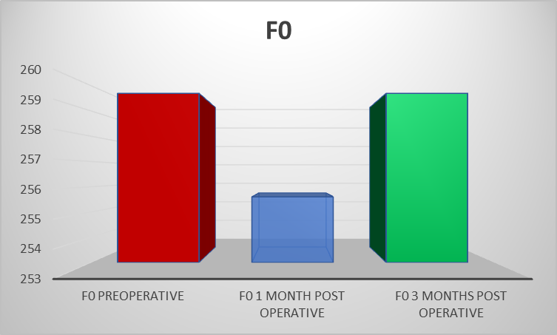
Figure 2 Comparison between preoperative and postoperative in FO. There were insignificant difference were obtained between 2 groups.

