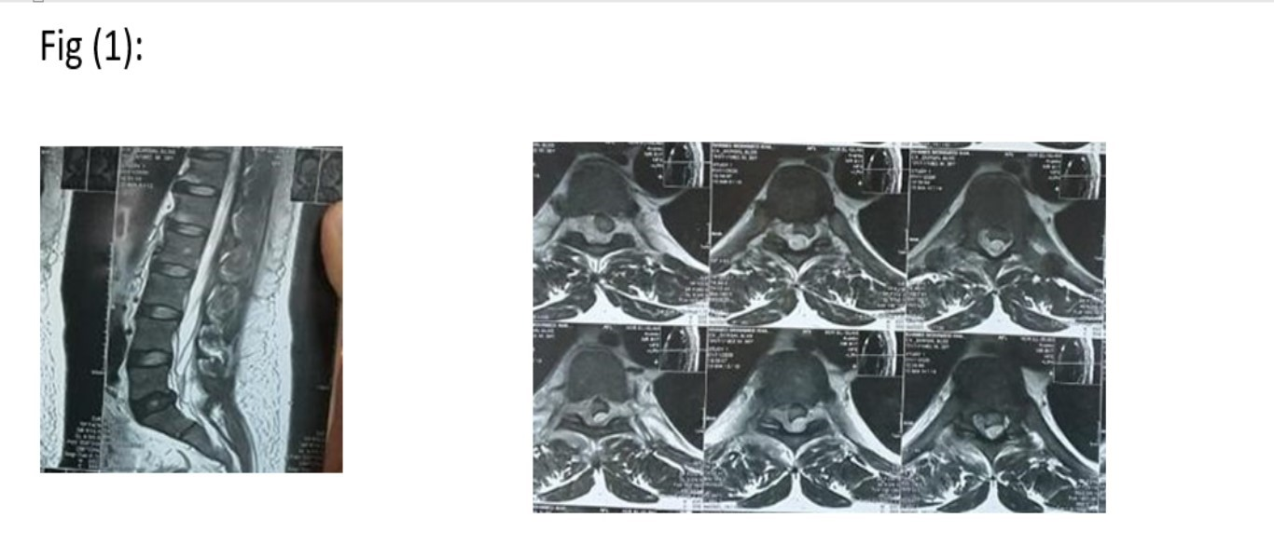

**Figure (1): Saggital and axial T2 wieghted images of lumbar spine MRI showing posttraumatic hyperintense epidural mass causing mass effect on cauda equina**

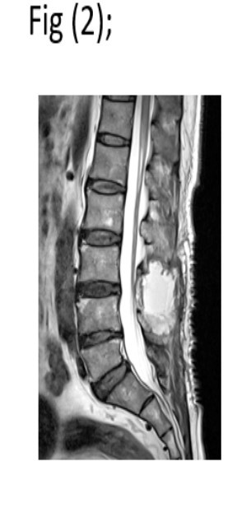

**Figure (2): sagittal T2 weighted image of lumbar spine MRI postoperative**

**to spinal epidural hematoma evacuation**

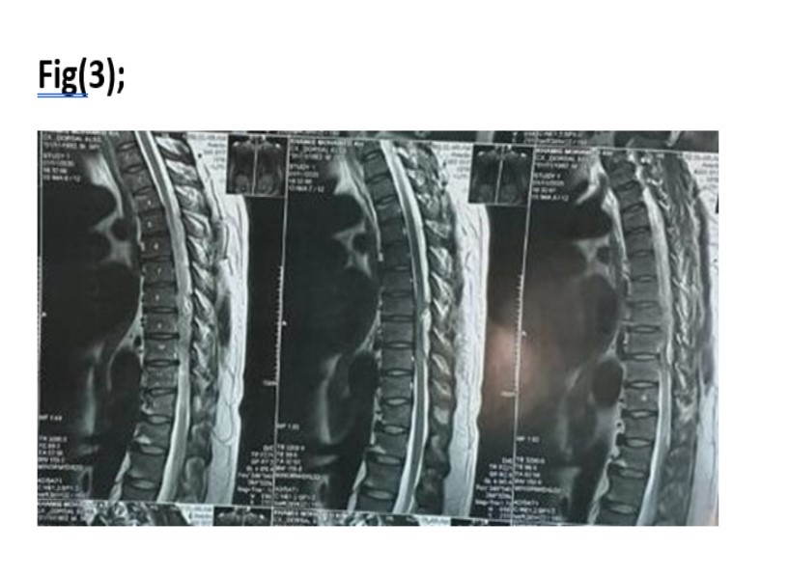

**Figure (3): Saggital T2 weighted image of dorsal MRI showing posttraumatic heterogenous hyperintense epidural lesion (hematoma) opposite dorsal 9,10,11 vertebrea**

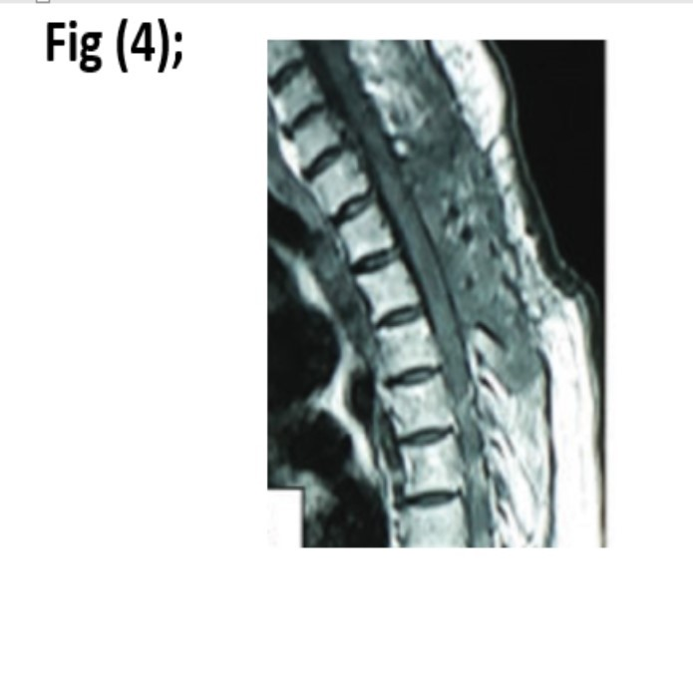

**Figure (4): saggital T1 wieghted image of dorsal MRI postoperative to spinal epidural hematoma evacuation showing laminectomy of D9,10,11 and complete evacuation of hematoma**

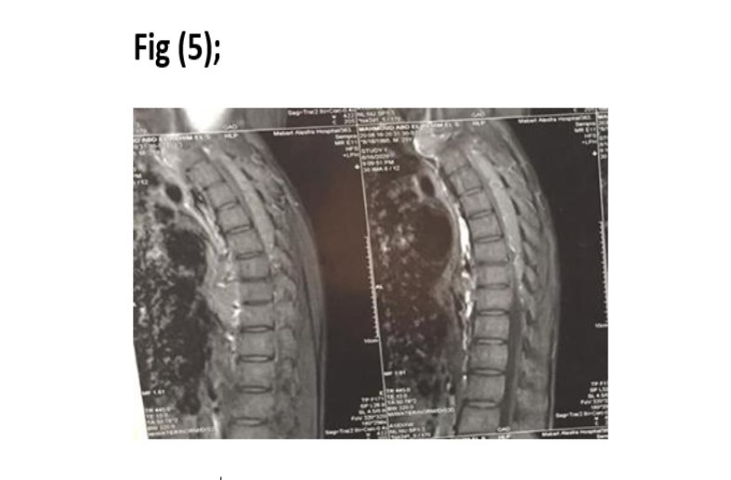

**Fig (5): Saggital T2 Weighted image of dorsal Mri showing posttraumatic epidural hyperintense lesion (hematoma) opposite dorsal 5,6,7,8,9**

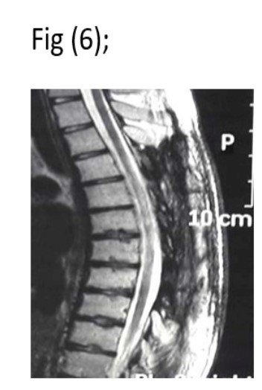

**Fig (6): Postoperative saggital T2 weighted image of dorsal MRI showing laminectomy of dorsal vertebrae 5,6,7,8,9 and total evacuation of epidural hematoma**.

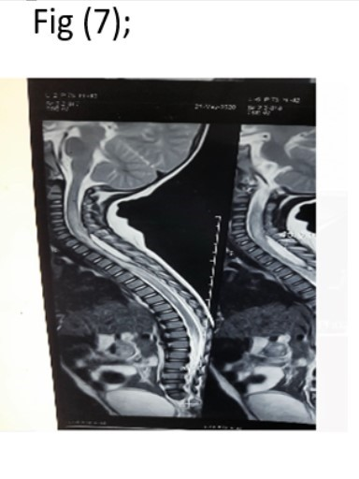

**Fig (7): Saggital T2 weighted image of Cervico-dorsal MRI showing spontaneous hyperintense epidural lesion (hematoma) opposite C7, D1,2,3,4**

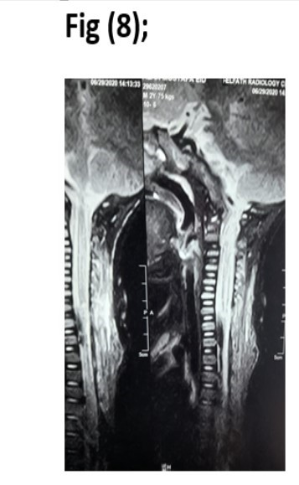

**Fig (8): Postoperative saggital T2 weighted image of cervico-dorsal MRI showing laminectomy of affected levels and complete evacuation of hematoma**