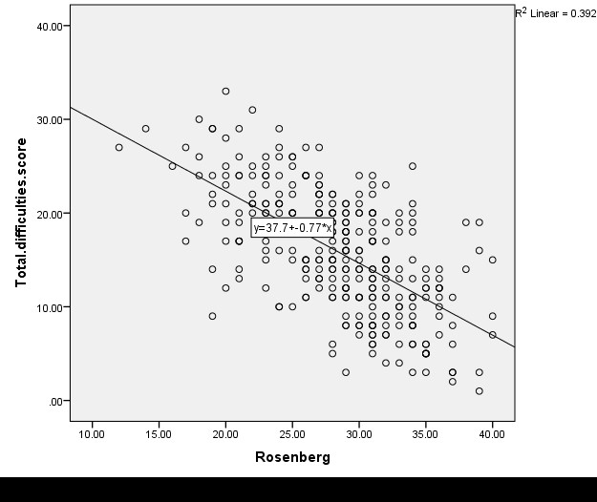

**Figure (1) Correlation between total difficulties score and self esteem**

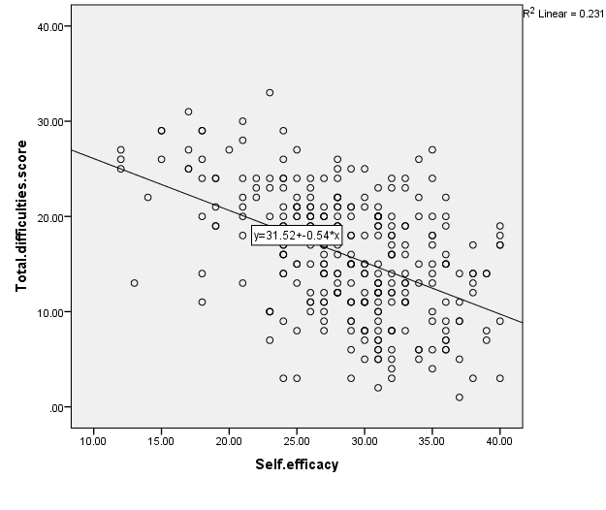

**Figure (2) Correlation between total difficulties score and self-efficacy scale**

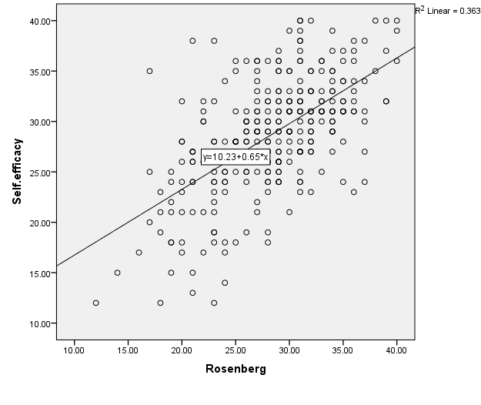

**Figure (3) Correlation between self-esteem and self-efficacy scale**