**(Fig. 1A, B) [3]**

A

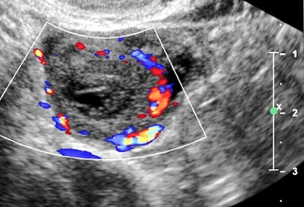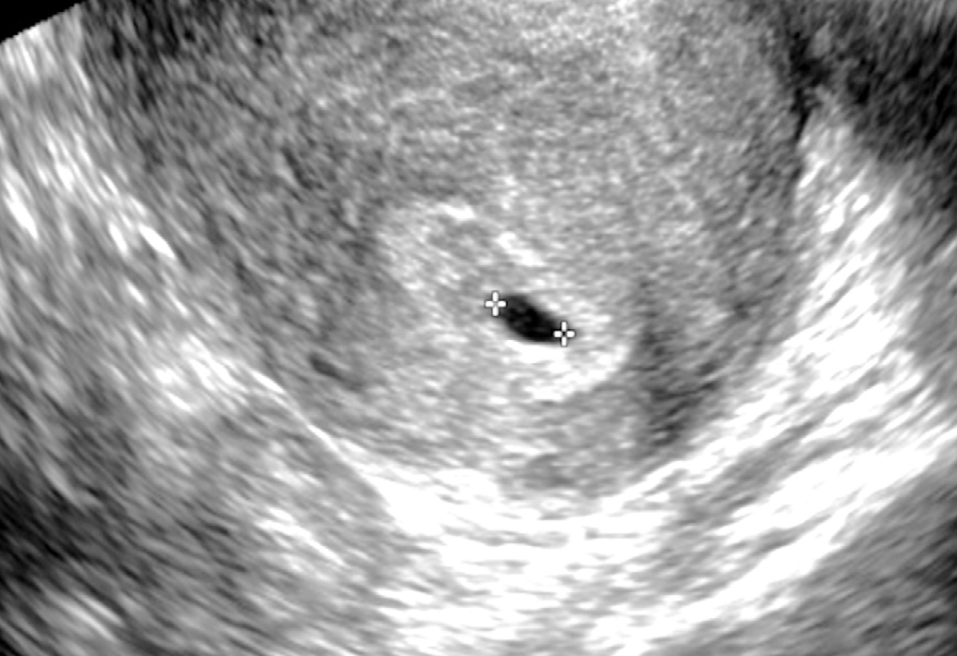

A B

Fig. 1. Normal early gestational sac and corpus luteum.

1. Transvaginal ultrasonography (TVUS) demonstrates an anechoic structure with peripheral echogenic tissue (arrowheads) representing a gestational sac in the uterine cavity of a woman with a positive urine pregnancy test. B. TVUS shows a circumscribed heterogeneous structure with peripheral vascularity in the right ovary compatible with a c
2. Corpus luteum (arrowheads).

**(Fig. 2A, B).**

|  |  |
| --- | --- |
|  |  |

A B

Fig. 2. The double decidual sac sign.

A. Transvaginal ultrasonography demonstrates two concentric echogenic rings (arrowheads) with intervening trace hypoechoic material, known as the double decidual sac sign.

B. Graphical representation of the double decidual sign is shown.This is known as the double decidual sac sign (DDS), which is a definitive sign of an intrauterine pregnancy (IUP).While the presence of the DDS sign confirms an IUP, its absence does not exclude an IUP [4].

**(Fig. 3A, B) [4].**

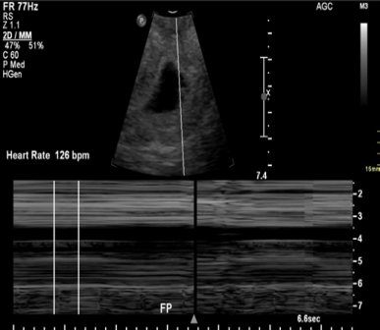

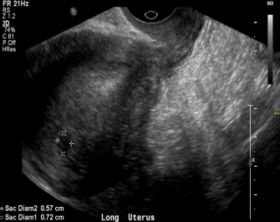

A B

Fig. 3. A 19-year-old woman with vaginal bleeding and a positive beta-human chorionic gonadotropin test.

A. Initial transvaginal ultrasonography (TVUS) shows a vague hypoechoic collection measuring 7 mm in the uterine fundus (arrow). The morphology was not typical for an intrauterine pregnancy.

B. Subsequent TVUS 2 weeks later demonstrates an intrauterine gestational sac with an embryo with heart rate of 126 bpm.

**(Fig. 4) [2,5].**

|  |  |
| --- | --- |
|  |  |

A B

Fig. 4. Transvaginal ultrasonography in a pregnant woman presenting with abdominal pain and cramping.

A-Initial ultrasonography shows a gestational sac without a yolk sac or embryo.

B. Follow-up ultrasonography 2 weeks later shows a gestational sac measuring greater than 25 mm in diameter without evidence of a yolk sac or embryo.

**(Fig. 5) [7].**

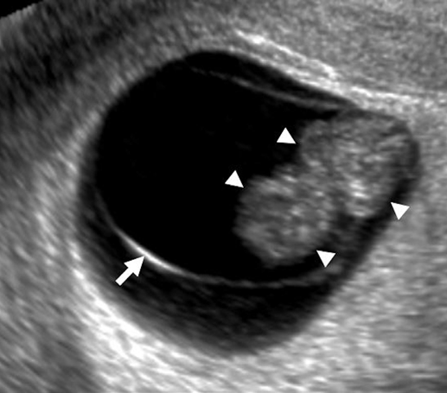

Fig. 5. Transvaginal ultrasonography in a patient with a previously confirmed intrauterine pregnancy (IUP) and vaginal bleeding, showing an IUP with a fetal pole (arrowheads). A curvilinear echogenic membrane is noted around the embryo, corresponding to the amniotic membrane (arrow).

**(Fig. 6A, B) [7].**

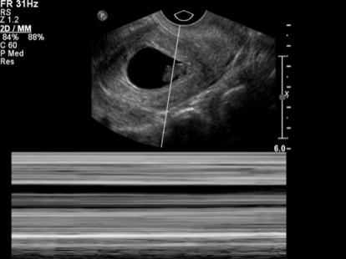

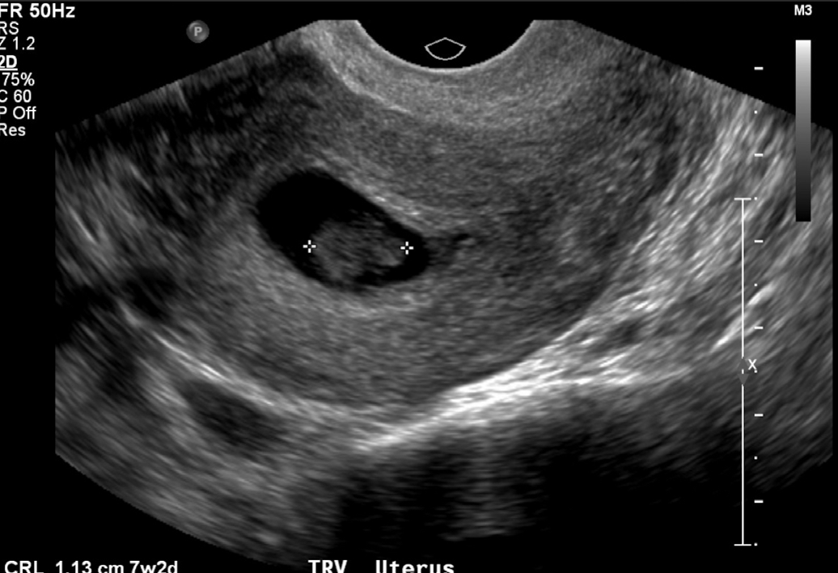

A B

**Fig. 6:. Early pregnancy failure.**

A. Transvaginal ultrasonography shows an intrauterine pregnancy with an embryo (arrow) with a crown-rump length of 1.1 cm, corresponding to a gestational age of 7 weeks, 2 days.

B. No fetal heart rate was identified; compatible with intrauterine embryonic demise. The fetal heart rate gradually increases with gestational age from approximately 110 beats per minute (bpm) at 6.2 weeks to approximately 159 bpm at 7.6-8.0 weeks

**(Fig. 7A, B):**

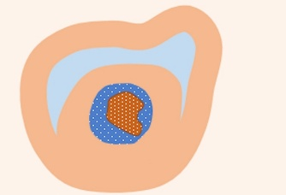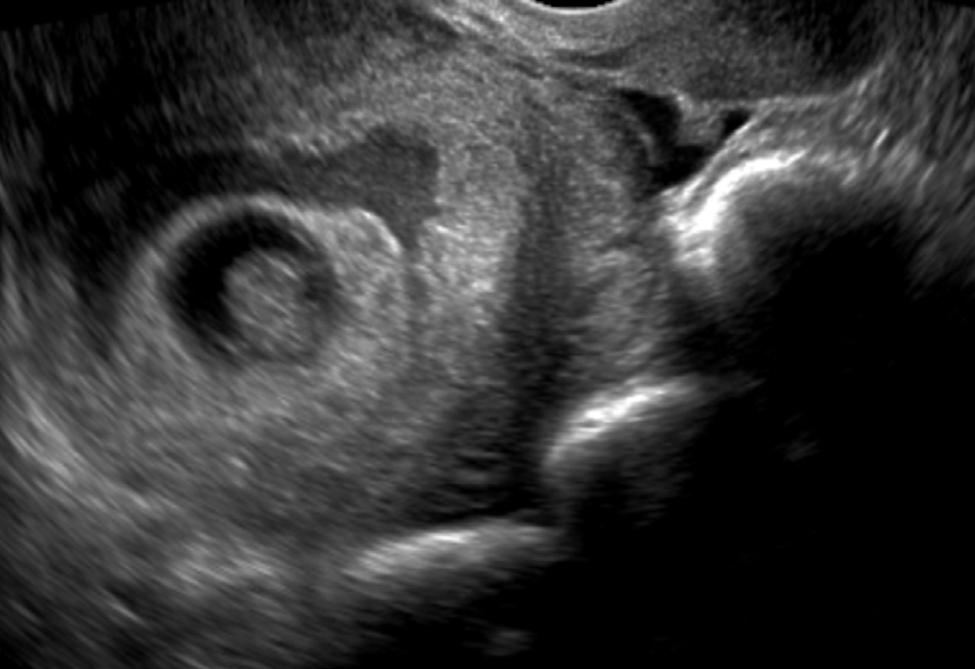

A B

Fig.7. Subchorionic hemorrhage.

A. Transvaginal ultrasonography in a pregnant woman shows a gestational sac with an embryo and a heterogeneous subchorionic collection (arrowheads) encircling approximately 180° of the gestational sac.

B. Graphic depiction of the findings in A is shown. Larger subchorionic hematomas are associated with an increased risk of pregnancy loss, especially if the hematoma is greater than twothirds of the chorionic circumference [13, 14].

**(Figure 8 ):**

|  |  |
| --- | --- |
|  |  |
|  |  |

Figure 8: Median measurements of the parameters under investigation in the two groups, pregnancy loss and continuing pregnancy, plotted against the gestational age: (A). Gestational sac (GS); (B). Yolk sac (YS); (C).Crown-rump length (CRL); (D). Heart Rate (HR).