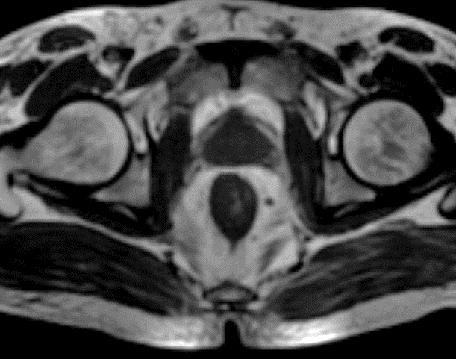

A

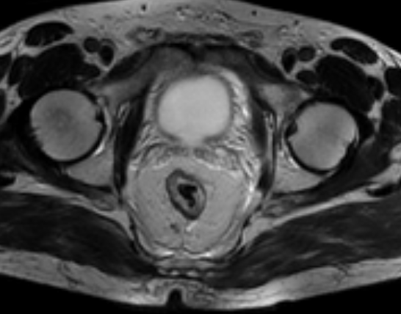

D

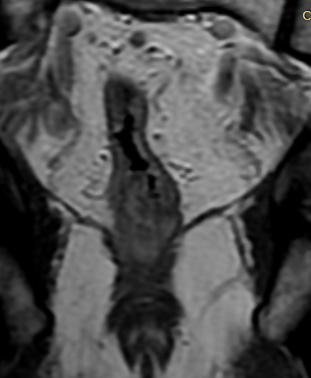

B

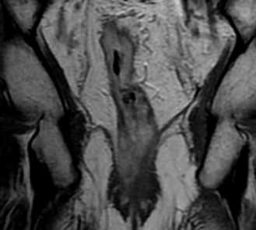

E

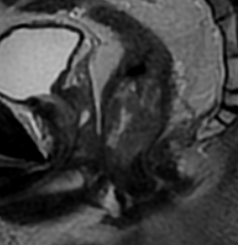

C

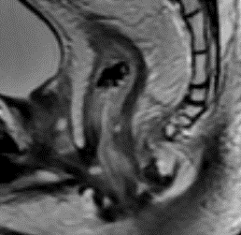

F

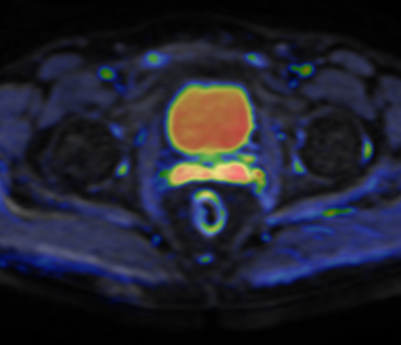

J

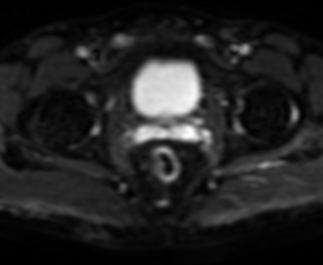

I

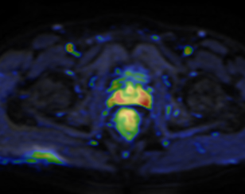

H

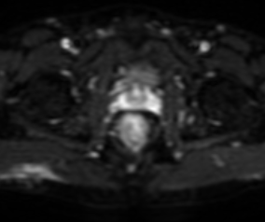

G

L

K

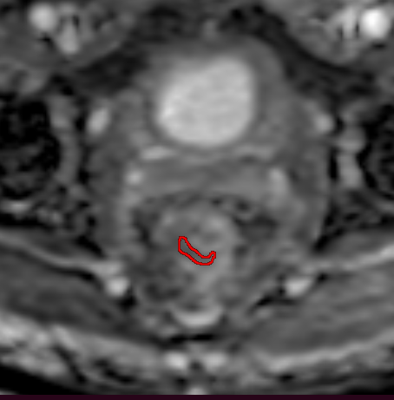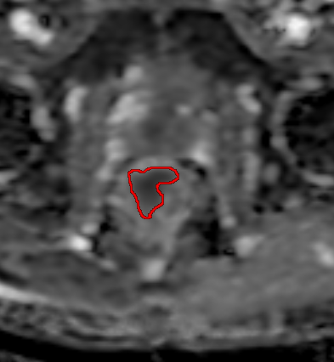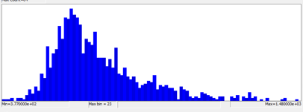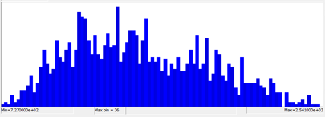

|  |  |  |  |  |  |
| --- | --- | --- | --- | --- | --- |
|  |  | **Group** | | | P value |
| **DP** | **DR** | **CR** |
| **Volume cm3(pre)** |  | 65  (49-82.8) | 33  (21.5-52.5) | 40  (29.5-47.5) | **0.017\*** |
| **Volume cm3 (post)** |  | 75  (49.3-90) | 12  (6-18.5) | 0  (0-0) | **<0.001\*** |
| **DP**: Disease progression, **DR**: Disease regression, **CR**: Complete response | | | | | |