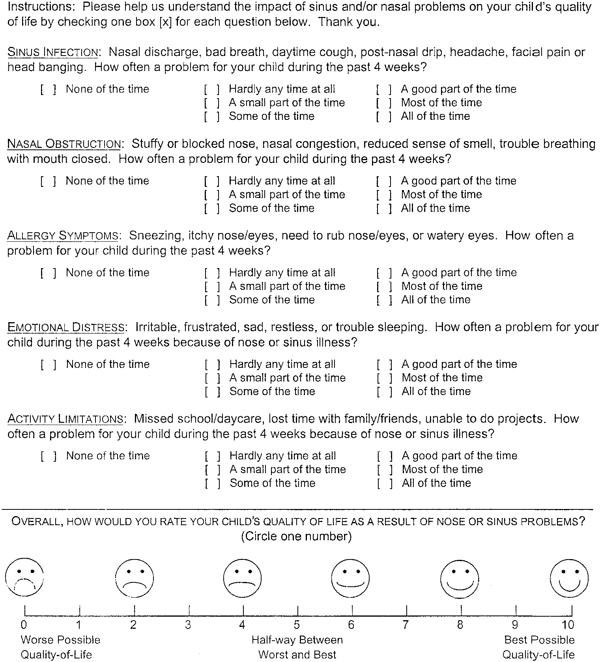
Figure (1): the sinus and nasal quality of life survey (SN5) [9].

Figure (2): Gender distribution of the studied population.

