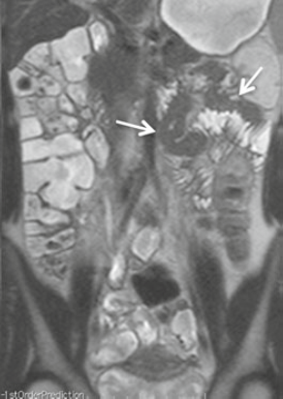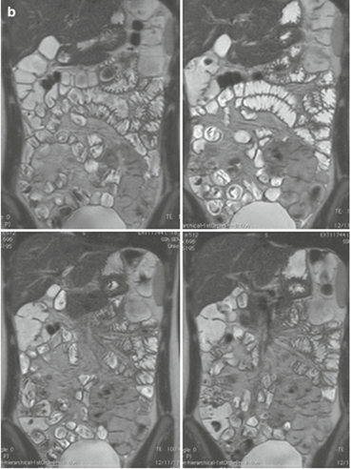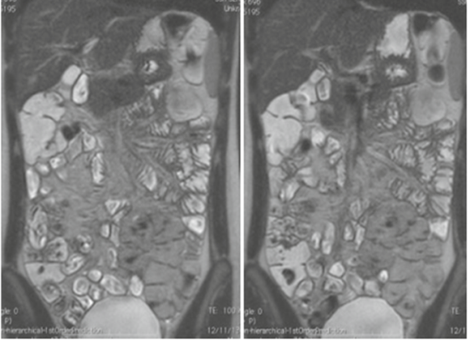
b
a

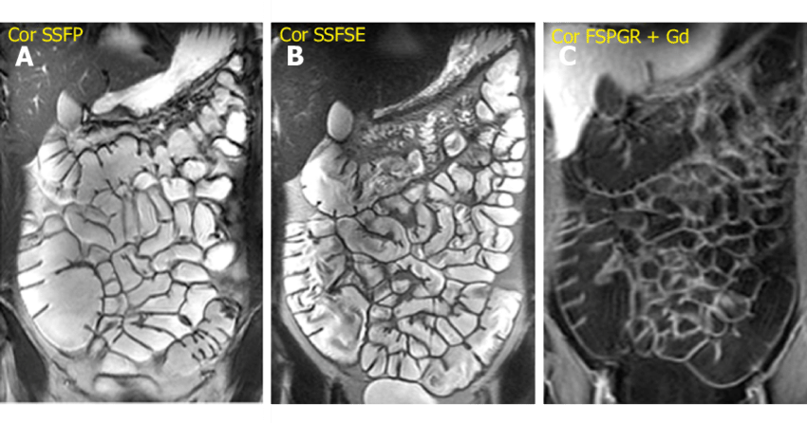

A

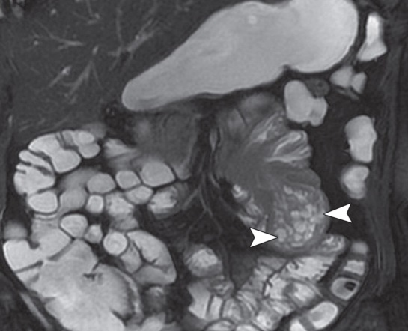
a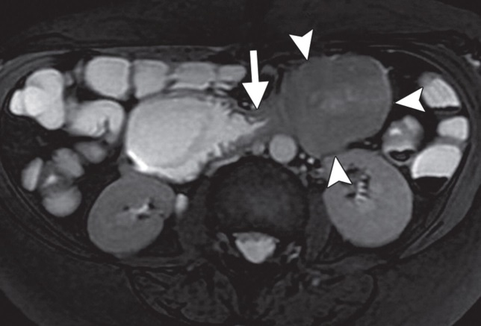 b

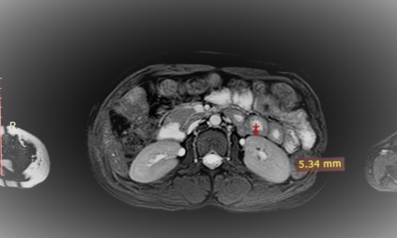

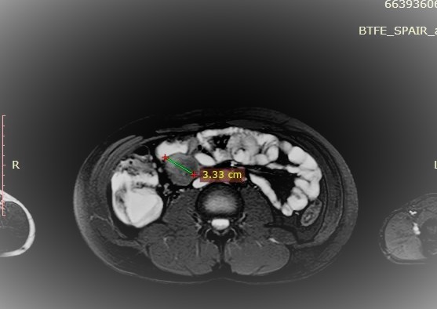

 | US | CT | MRE
Sensitivity | 32 % | 72 % | 80 %
Specificity | 60 % | 60 % | 100 %
Positive predictive value | 80 % | 90 % | 100 %
Negative predictive value | 15 % | 30 % | 50 %
Accuracy | 36.6 % | 70 % | 83.3 %

