Clinical data:
First case, female patient 40 years old, complained of left lion pain with sonographically detected left mild nephropathic changes, referred for renal scan.
- First image reveals posterior calculation of split function by Tc99 DMSA of both kidneys
Left kidney: 25.5 Right kidney:74.5

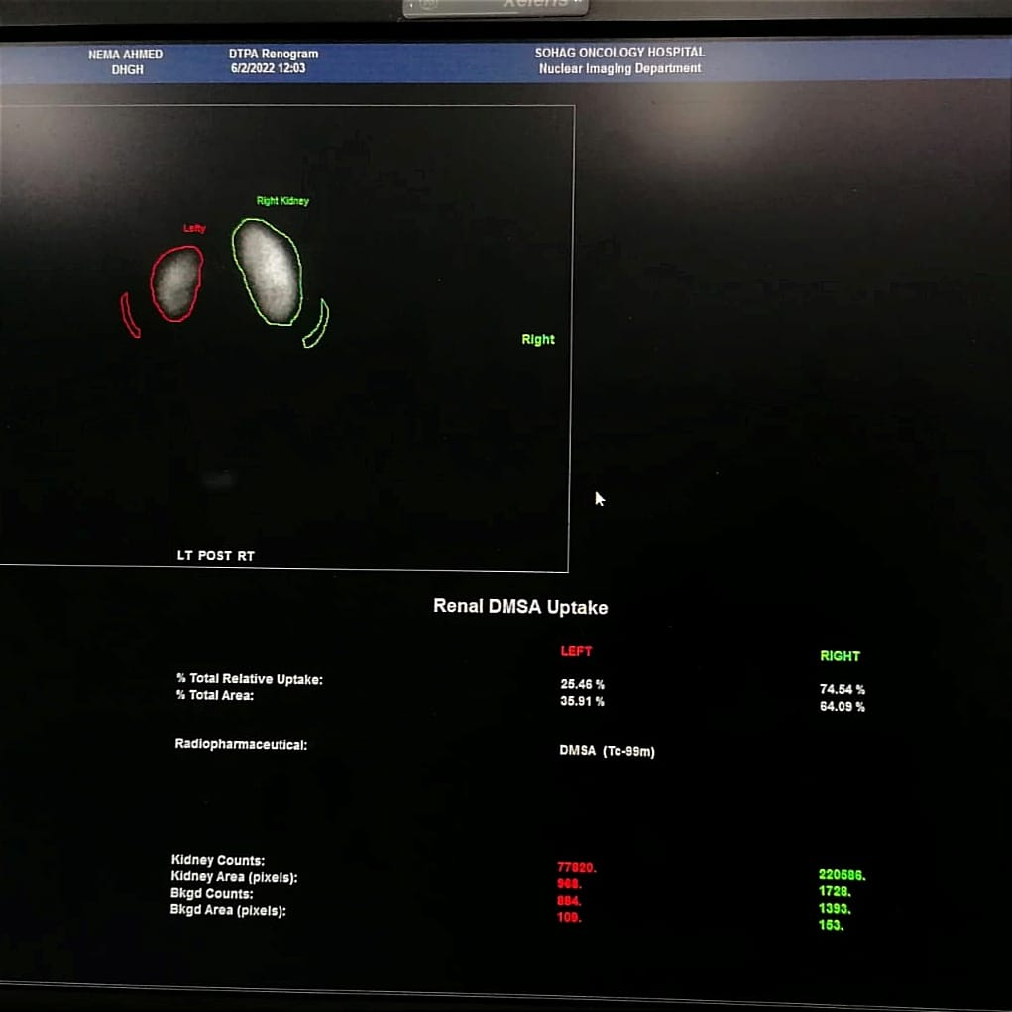

- Second image reveals geometric mean between anterior & posterior calculation for each kidney separately.

Left kidney: 28.5 Right kidney:71.5

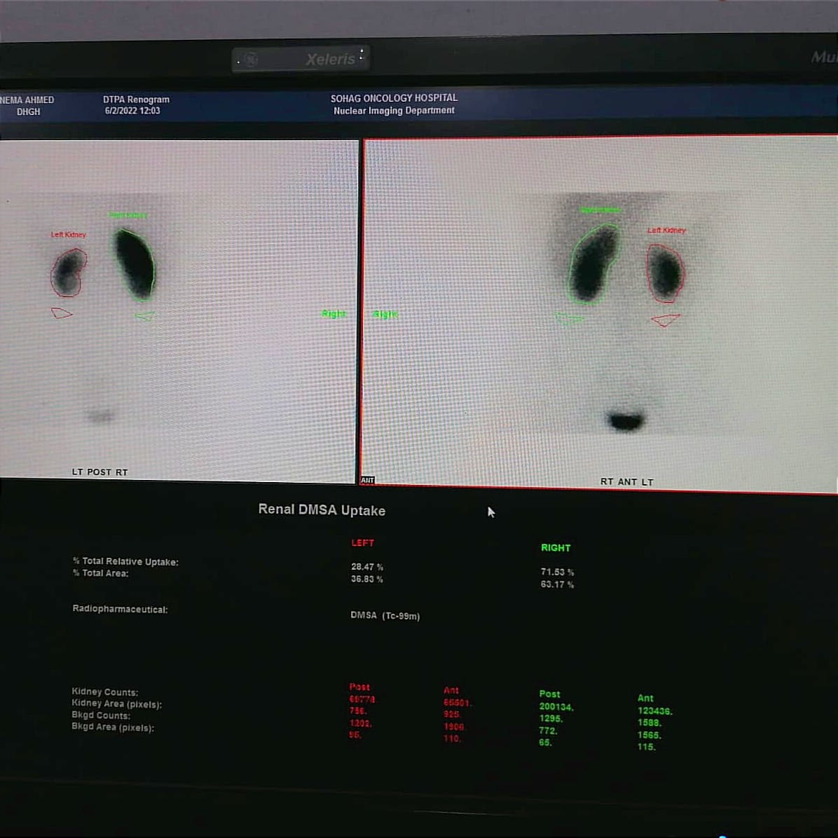
In view of the statistical finding as described in results, there is no significant P Value between the two methods regarding estimation of Differential Renal function.

Second case, male patient 20 years old, complained of dysuria with sonographically detected Horse-Shoe Kidneys, referred for renal scan.
- First image reveals posterior calculation of split function by Tc99 DMSA of both kidneys
Left kidney: 23.02 Right kidney:76.98
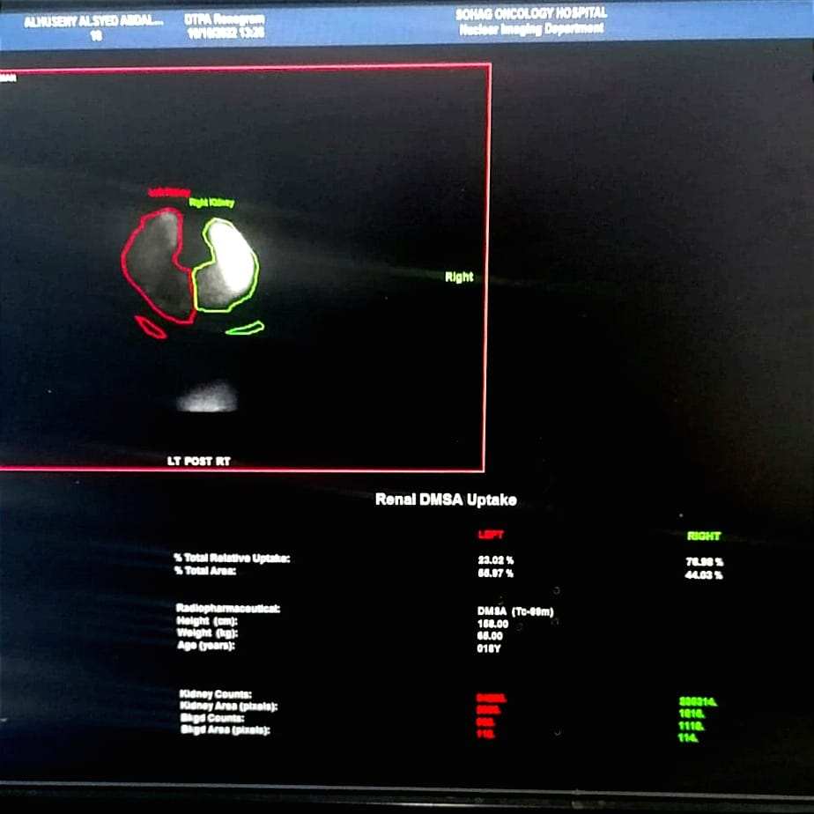

Second image reveals geometric mean between anterior & posterior calculation for each kidney separately.

Left kidney: 24.97 Right kidney:75.03
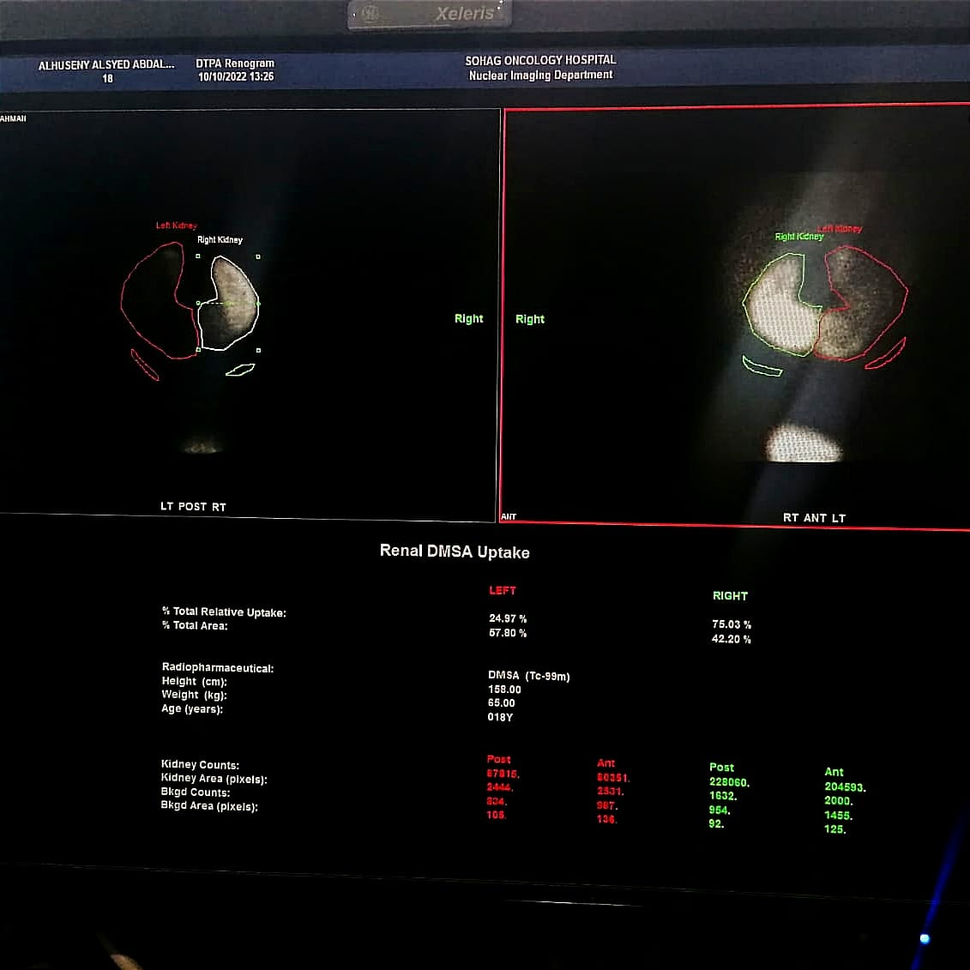
Despite most of abnormally located kidneys; ectopic and Horse-Shoe kidneys revealed statistical difference between the two methods regarding estimation of Differential renal function in our study, some cases like that abovementioned revealed no significant difference, which signifies the importance of difference in renal depth implicating the benefit of using geometric mean especially in abnormally located kidneys.

